**Noteguide for Bohr Atom - Videos 27KL Name**

**27K:** Bohr develops a quantum theory for the atom to explain the spectral lines.

The spectral lines follow a pattern:

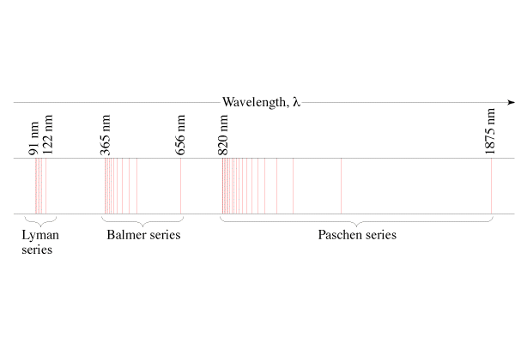

1/λ = R(1/22 - 1/n2), n = 3, 4, ...(Balmer) (Visible)

1/λ = R(1/12 - 1/n2), n = 2, 3, ...(Lyman) (UV)

1/λ = R(1/32 - 1/n2), n = 4, 5, ...(Paschen) (IR)

**Three Assumptions of the Bohr Model:**

**1.** Electrons exist in stationary states that don't radiate energy.

(More about this later - these are resonances)

**2.** Photons are created from the energy given off by downward electron transitions:

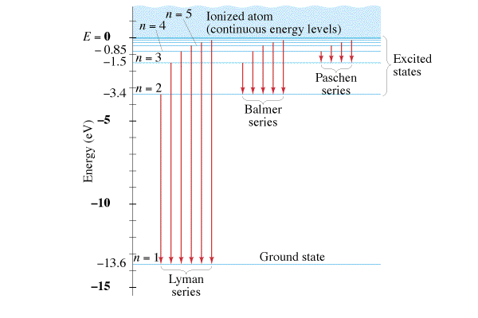

Example 1 – What is the wavelength of the first Lyman line?

**3.** Angular momentum of the electrons is quantised. (Even multiples of h-bar)

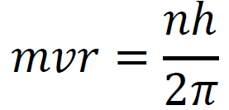Example 2 - Show that mvr = L = Iω,

**Ultimately, the energy levels can be simplified to:**

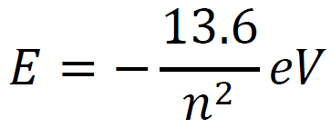n - principal quantum number (orbital)

E - Total energy of electron (KE + PE) in eV

Example 3: What is the energy level of the 4th orbital, and the 2nd orbital?

What wavelength of light corresponds to a 4 to 2 transition for a Hydrogen atom? (The 2nd Balmer line)

**Limitations of the Bohr Model:**

* Works well for H, but doesn’t even work for He
* Did not explain
  + Spectral fine structure
  + Brightness of lines
  + Molecular bonds
* Theory was not complete.
* But otherwise it generally kicked tuckus

Whiteboards:

|  |  |
| --- | --- |
| 1. What possible photon energies can you get from these energy levels? (there are 6 different ones)    (1, 4, 9, 3, 8, 5 eV) | 2. What is the wavelength of the photon released from the third Lyman spectral line  (from -.85 to -13.6 eV)? (97 nm) |
| 3. What is the wavelength of the photon associated with an electron transition from n = 6 to n = 1 in a hydrogen atom? Is the photon being absorbed, or emitted?(93.8 nm, emitted) | 4. What is the wavelength of the photon associated with an electron transition from n = 2 to n = 3 in a hydrogen atom? Is the photon being absorbed, or emitted?(657 nm absorbed) |

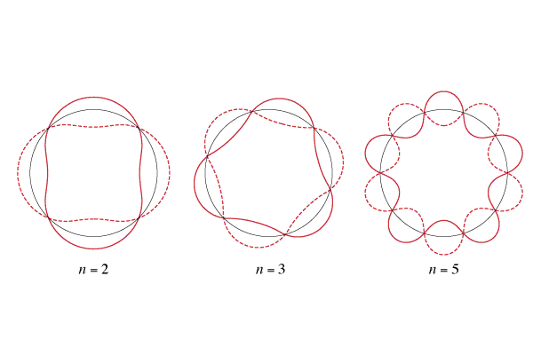**27L:** Show that the quantisation amounts to the circumference of the orbit being integer multiples of the de Broglie wavelength. (Bohr did not base his quantum hypothesis on this - it was used after the fact to explain and justify)





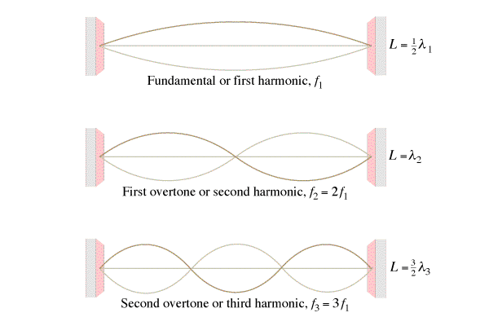

Schrodinger Wave Equation:

