Noteguide for Nuclear Radius - Videos 27I Name

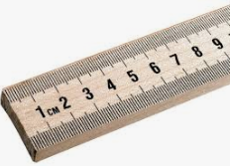
Atoms are ≈ 10⁻¹⁰ m in radius

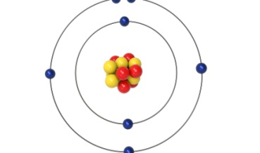
Nuclei are ≈ 10⁻¹⁵ m in radius

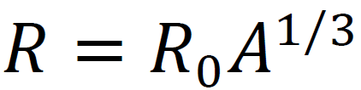

R - Nuclear radius (m)
R_{o} - Fermi Radius (1.20x10⁻¹⁵ m)
A - Mass # (#p +#n)

Example 1: What is the radius of a Uranium 235 nucleus? (A = 235)

Whiteboard:
What is the radius of a Carbon-12 nucleus? (2.75 fm or 2.75x10⁻¹⁵ m)

