**Noteguide for de Broglie Waves - Videos 27H Name**

**de Broglie** – If light can act as a particle, then matter can act as a wave.

|  |  |
| --- | --- |
| The wavelength/momentum of a particle:    p = momentum (kg m/s)  h = Planck’s constant = 6.626x10-34 Js  λ = wavelength (m) | The momentum of a particle:    p = momentum (kg m/s)  m = mass (kg)  v = velocity (m/s) |
|  |  |

**Davisson-Germer:**

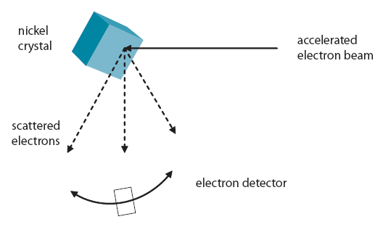

   

Example 1: What is the de Broglie wavelength of a 0.145 kg baseball going 40. m/s?

Example 2: What is the velocity of a proton (m = 1.673x10-27 kg) with a de Broglie wavelength of

600 nm?

Example 3: Through what potential must you accelerate an electron so that it has a wavelength of

1.0 nm?Whiteboards:

|  |  |
| --- | --- |
| 1. What is the de Broglie wavelength of an electron (m = 9.11x10-31 kg) going 1800 m/s?  (404 nm) | 2. What is the momentum of a 600. nm photon?  (1.10 x10-27 kg m/s) |
| 3. What is the mass of a particle that has a de Broglie wavelength of 450 nm, and a velocity of 40.0 m/s? (3.68x10-29 kg) | 4. Electrons in a microscope are accelerated through 12.8 V. (m = 9.11x10-31 kg) What de Broglie wavelength will they have?  (3.428x10-10 m) |

Part 2:

