Noteguide for Photon Interactions - Videos 27D1 Name
Photon Interactions with matter:
Photo-electric Effect - photon ejects electron from a metal surface
Compton Scattering - Photon scatters (bounces) off an electron. Electron and photon go off in different directions, and photon's wavelength goes down. (Loses energy...)
Absorption - Photon energy is the same as a transition energy, so it bumps an electron up an energy level and is absorbed
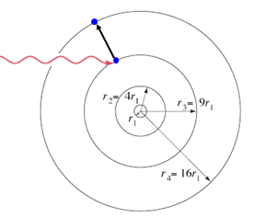
Pair Production - A photon passing by a mass (nucleus, or electron) spontaneously creates a matter-anti matter pair.
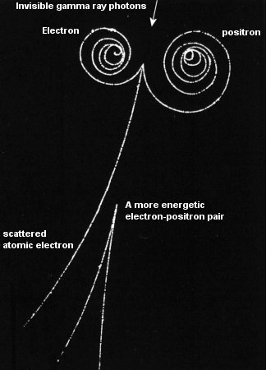
Complementarity - Either the wave model, XOR the photon model explains light
