Noteguide for Photons - Videos 27BCD Name
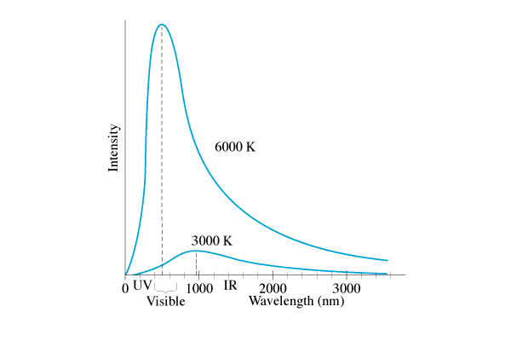
27B: Planck

27C: Photon Theory: Light is made of particles.
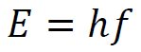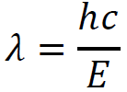
E = Photon energy (Joules)
h = Planck’s constant = 6.626 x 10⁻³⁴ Js
f = frequency of oscillations (Hz, s⁻¹)
c = speed of light = 3.00x10⁸ m/s
λ = Wavelength in m

Example 1: What is the energy (in eV) of a 460. nm photon?

Example 2: A photon has an energy of 13.6 eV. What is its wavelength?

Whiteboards:
1. What is the energy (in J) of a photon with a frequency of 6.58 x 10¹⁴ Hz? (4.36 x 10⁻¹⁹ J) | 2. What is the wavelength of a photon with an energy of 5.45 x 10⁻¹⁸ J? (36.5 nm or 3.65E-8 m)
3. What is the energy (in eV) of a 314 nm photon?  (3.95 eV) | 4. A photon has an energy of 6.02 eV. What is its wavelength? (206 nm)

27D: Photon vs. Wave theory:

 | Wave Model | Photon Model
Color: | Wavelength changes  Small λ = Blue  Big λ = Red | Energy per photon changes (E = hf = hc/λ)  High E = Blue/UV/X-rays  Low E = Red/Microwaves/radio
Brightness: | Amplitude Changes  Bright = big  Dim = small | # of Photons changes  Bright = many  Dim = few

