Nuclear Reactions – Nuclear reactions that lead to a decrease of mass are exoergic (They release energy), and those that lead to an increase of mass are endoergic (They require energy input).

Reaction notation:
42He + 147N ---> 178O + 11H Can be written as 147N(α, p)178O

In general:
Initial Nucleus(Bombarding particle, Emitted particle)Final Nucleus

Common Particles:
n = ¹₀n = 1.008665 u
p = ¹₁H = 1.007825 u
d = ²₁H = 2.014102 u
t = ³₁H = 3.016049 u
α = ⁴₂He = 4.002602 u
Example 1: Find the missing item in: ???(n, p)146C

Example 2: Finding the Q value of this reaction: 19779Au(α, d) 19980Hg
Hahn and Strassman’s Discovery:

n + 23592U ---> 14156Ba + 9236Kr + some neutrons How many Neutrons?

n = ¹₀n = 1.008665 u
U-235 = 235.043923 u
Ba-141 = 140.914406 u
Kr-92 = 91.926153 u

What is the Q value of this reaction?

What is the energy density in J/kg if this is the only reaction that occurs? (Many different fission reactions occur)

How to build a nuclear bomb:

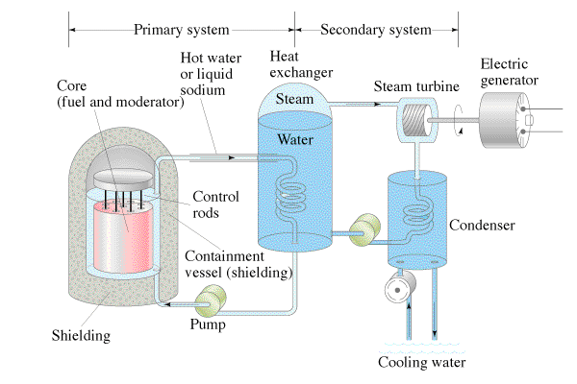
Nuclear Energy:

Advantages:

Disadvantages:

