Radioactivity – Some nuclei are unstable and decay into a particle and a daughter nucleus. The decay is possible only if the products have less total mass than the parent nucleus. (losing mass = releasing energy)

|  |  |  |  |  |  |
| --- | --- | --- | --- | --- | --- |
| Type | Symbol | What it is: | Effect on parent | Energy in MeV | Stopped By |
| Alpha | α | 2p2n (He nucleus) | A-4, Z-2 | 2-10 | 4 cm air |
| Beta- | β- | Electron | A-0, Z+1 | 0.1-1.0 | 1-3 m air/Thin Al |
| Beta+ | β+ | Positron | A-0, Z-1 | 0.1-1.0 | 1-3 m air/Thin Al |
| Gamma | γ | High energy photon | A-0, Z-0 | 0.001-3.0 | cm of lead |

**Alpha Decay** – A large nucleus releases energy by ejecting a He nucleus (2p2n, m = 4.002602 u)

Example of energy:

  + 

**Beta Decay** – A nucleus creates an electron or positron out of pure energy.

  + β- + υe

  + β+ + υe

**Gamma Decay** – The nucleus goes from a more excited state to a less by releasing the energy as a high energy small wavelength photon. (5 - .05 nm) These are usually associated with an alpha or beta decay.

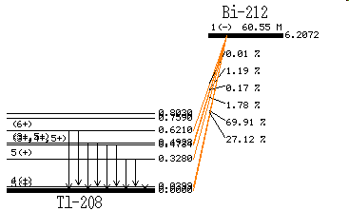Example: Tl-208 emits a 0.6210 MeV gamma and the neutral atom has a mass of 207.9820047 u. What was the mass before the gamma was emitted?

Gamma rays secondary to the alpha decay of Bi-212.

Energies are in MeV