**Special Relativity Part I – Time and Mass dilation, Length Contraction**

(Videos A, B, C from Chapter 26)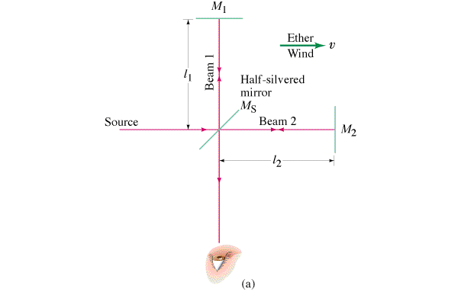

**Michelson-Morley** – Attempted to find our velocity relative to the “ether” – a supposed medium for light.

**Einstein’s Gedanken –** If we could catch up with a light wave what would we see?

**First Postulate of Relativity:**

The laws of physics are the same in all inertial frames of reference

There is no experiment you can do to ascertain whether you are moving.

(i.e. all motion is relative)

**Second Postulate of Relativity:**

The speed of light is the same no matter what speed the source or observer is going

(i.e the speed of light is a law of physics)

**So if the speed of light is constant regardless of the velocity of the observer and the source, then other things that we don’t think should change, must change. Moving clocks run slower, moving particles gain mass, and a moving reference frame shrinks in the direction of motion. Time, mass and length are all relative.**

**Time Dilation – moving clocks run slower.**

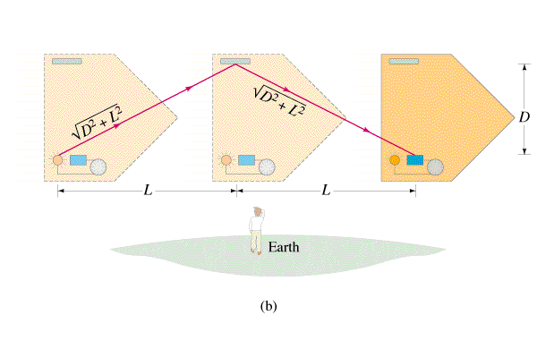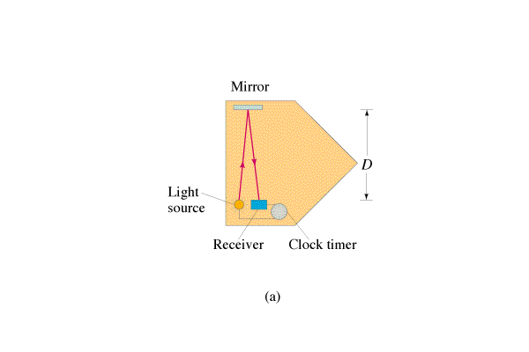

**Write the derivation here:**

|  |  |
| --- | --- |
| Lorentz Factor: (Approaches infinity as v -> c)    c = the speed of light (3.00x108 m/s)  v = velocity of moving frame (m/s) | Moving Clocks run **slower**: (Time dilation)    Δto = proper time (un dilated)  Δt = dilated time  γ = Lorentz factor |
| Moving objects **gain mass**: (Mass dilation)    mo = rest mass (un dilated)  m = dilated mass  γ = Lorentz factor  (not in data packet?) | Moving objects **contract in length**:    Lo = rest length  L = contracted length  γ = Lorentz factor |
| The happiness momentum formula:    p = momentum  mo = rest mass (un dilated)  u = velocity,  γ = Lorentz factor | Only the dimension parallel to the velocity shrinks:  At rest Moving |

Example 1: If you drive by the school at 40.0 m/s, how long do we see your watch take to register 10.0 seconds? What about 40,000. m/s? 0.200 c? 0.500 c?

Example 2: If we see your watch take 12 seconds to register 10. seconds, how fast are you going?

(Show solution for c here)

Example 3: A car going past us at 0.60 c is 5.0 m long. How long would it be at rest?

Example 4: What is the speed of an electron if it has a mass of 0.634 MeV. (Its rest mass is 0.511 MeV) (What is its kinetic energy? through what potential was it accelerated?)

**Special Relativity Part II – Simultaneity, Kinetic Energy and Relative Velocity**

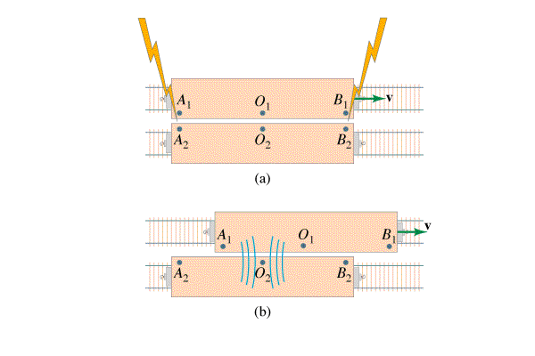(Videos F, G, H, I from Chapter 26)

**Simultaneity** – Simultaneity is relative. What is simultaneous in one frame of reference is not in another.

**Kinetic Energy** – When a mass dilates, the additional mass is energy mass.

|  |  |
| --- | --- |
| Rest Energy of object    Eo = Rest energy (J)  mo = rest mass (kg)  c = the speed of light (3.00x108 m/s) | Lorentz Factor    c = the speed of light (3.00x108 m/s)  v = velocity of moving frame (m/s) |
| Moving energy (total energy)    E = total energy (KE + rest) (J)  mo = rest mass (kg)  γ = Lorentz factor | Kinetic Energy    Ek = Kinetic Energy (J)  mo = rest mass (kg)  c = the speed of light (3.00x108 m/s)  γ = Lorentz factor |
| u = velocity, p = momentum |  |

**Example** – What is the kinetic energy of a 10.0 kg object going 0.60 c?

**Example** – A 0.144 kg baseball has 2.0x1015 J of kinetic energy. What is its mass, what is its velocity?

**Example** – An electron (rest mass 0.511 MeV) is accelerated through 0.155 MeV, What is its velocity?

**Relative Velocity**

|  |  |
| --- | --- |
| For velocity within the Frame    u’ = velocity of the object relative to the moving frame  u = velocity of object relative to us  v = velocity of the moving frame  c = the speed of light (3.00x108 m/s) | Addition: (not in data packet)    u’ = velocity of the object relative to the moving frame  u = velocity of object relative to us  v = velocity of the moving frame  c = the speed of light (3.00x108 m/s) |

**Example –** Tom is on a flatbed car going 0.85 c to the east. He throws a javelin at 0.56 c forward (relative to him, in the direction he is going) How fast is the javelin going with respect to the ground?

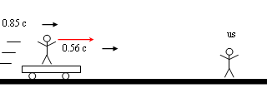

**Example –** Mary is on a flatbed car going 0.67c toward us, and when she throws a baseball at us, we measure it going 0.82c. With what speed did Mary throw it in her frame of reference?

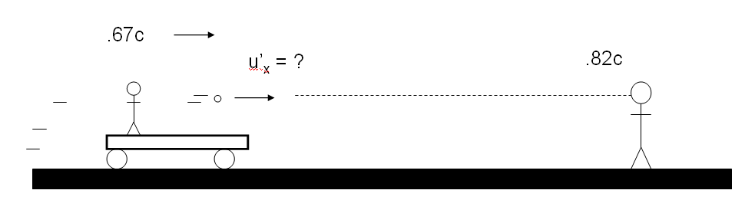

## Note guide for General Relativity

(Videos A, B, C, D, E from Chapter 33)

**Principle of Equivalence:**

* There is no experiment that will discern the difference between the effect of gravity and the effect of acceleration.
* Gravitational and inertial mass are equivalent.

**Apparent Curvature of light:**

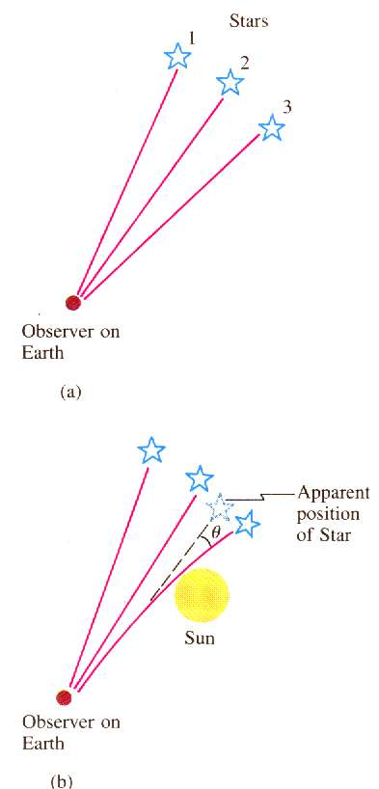

**Curvature of Space:**

|  |  |
| --- | --- |
| Schwarzschild Radius:   Rs = Schwarzschild radius (m)  G = 6.67x10-11 Nm2kg-2  c = 3.00x108 m/s  M = black hole mass (kg)  (Point of no-return near a black hole – if you go within this radius you cannot escape – or rather the escape velocity is greater than the speed of light. You can quantumly tunnel out – this is called Hawking radiation and it happens because of the Heisenberg uncertainty principle) | **Example:** What is the maximum radius of a black hole that is 30. million times the mass of the sun?  Msun = 1.99 x 1030 kg |

|  |  |
| --- | --- |
| Frequency Shift due to gravity field:   Δf = frequency shift (Hz)  g = gravitational field strength (N/kg)  Δh = distance parallel to the gravity field (m)  f = original frequency (Hz)  c = 3.00x108 m/s  (As photons climb out of a gravity field, they lose energy and their frequency gets slower – remember E = hf )  Remember – **low** clocks run s**low** | **Example:** A radio station at the bottom of a 320 m tall building broadcasts at 93.4 MHz. What is the change in frequency from top to bottom?  What frequency do they tune to at the top? (use g = 9.8 N/kg, and then g = 2.5x1013 N/kg) |
| Gravitational Time Dilation:   Δt = Time we observe at a distance (s)  Δto = Actual time that elapses near the black hole (s)  Rs = The Schwarzschild radius (m)  r = Distance from the black hole center that Δto happens  (We are outside the gravity of the black hole (at some large distance) and we are observing a clock some distance ***r*** from the black hole center. Since l**ow** clocks run s**low**, the clock might register 5 (***Δto***) minutes, but take 15 (***Δt***) minutes to do it) | **Example:** A graduate student is 5.5 km beyond the event horizon of a black hole with a Schwarzschild radius of 9.5 km. If they are waving (in their frame of reference) every 3.2 seconds, how often do we see them waving if we are far away? |