Note guide for The Standard Model (Part II)
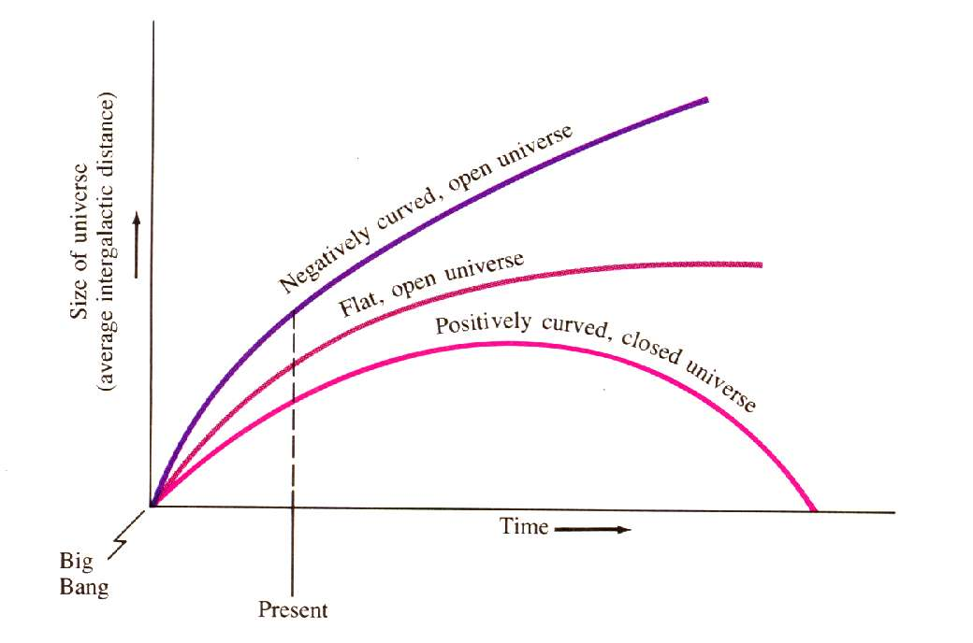
The Future of the Universe:

Curvature of Space:
Flat space Positive Curvature Negative Curvature

C = 2πr

Triangles = 180º

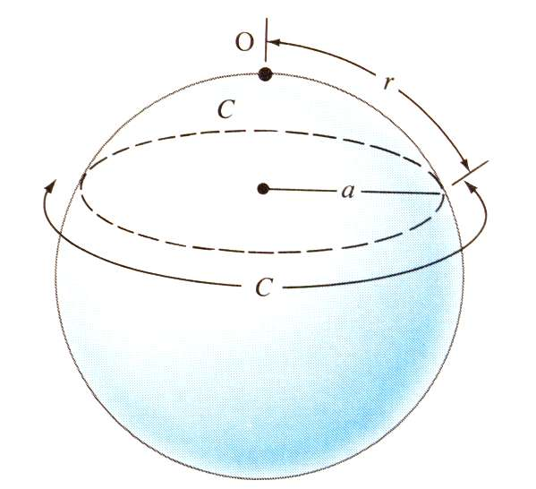
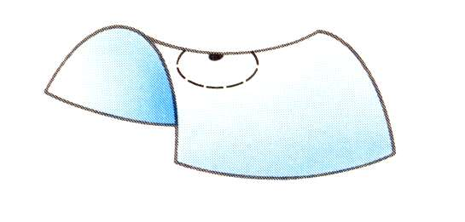

The Search for 3 numbers:
Ho - The Hubble constant. The current rate of expansion. We think it is 70.1±1.3 km/s/Mpc

qo - The deceleration parameter. Rate of braking due to gravity

λ - The cosmological constant. Anti-gravity. (Nobody likes this one much)

Ω – Combination of H_{o} and q_{o}. Index of space’s “flatness”
Inflationary Hypothesis (to explain why the universe is so flat)

Age of the universe.

Problems with the big bang:

Missing Matter

Big Bang Paradoxes

