Stars Part II – Stellar Evolution
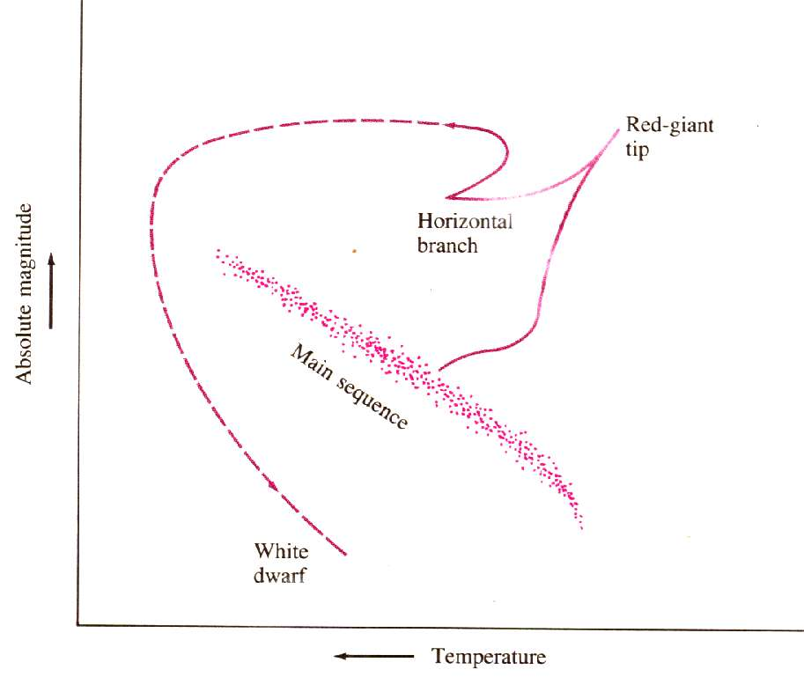
Overview:
- Protostar
- Main sequence star
- Red giant
•White dwarf or…
•Supernova -
•Neutron star or
•Black hole

Protostar Formation

Life on the Main Sequence
- Energy comes primarily from the Proton-Proton cycle:
- 1H + 1H = 2H + e+ + ν
- 1H + 2H = 3He + γ
- 3He + 3He = 4He + 1H + 1H
- (requires heat and pressure)
- Heat energy balances gravity
- 4He accumulates at the core of the star.

Rate Of Burn
- Big stars are Brief, Bright, and Blue
- Diminutive stars are Durable, Dim and reD
- L = m^{n} where 3 < n < 4

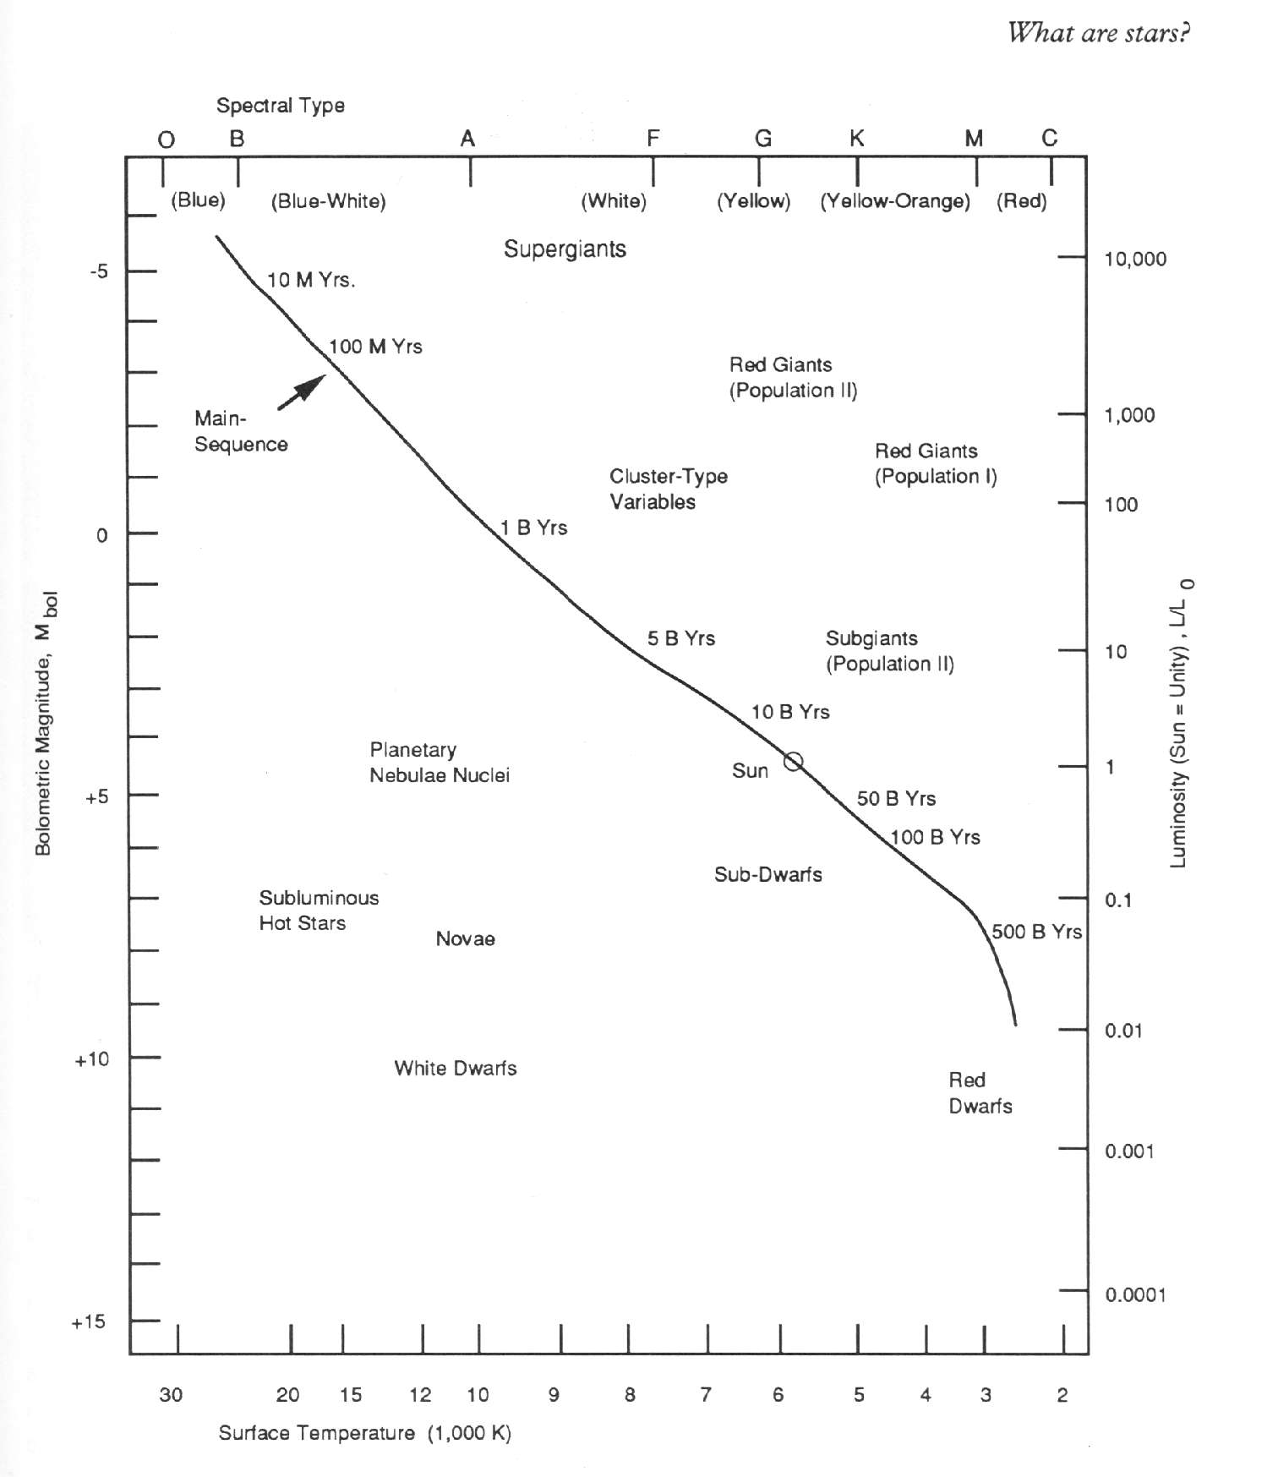

The Death of a star

Turning into a Red Giant

Helium Fusion
- He core gets hot and dense enough, He begins to fuse:
- 4He + 4He = 8Be + γ
- 4He + 8Be = 12C + γ

- 4He + 12C = 16O + γ (mainly)
- 4He + 16O = 20Ne + γ
- 4He + 20Ne = 24Mg + γ

Carbon Fusion (IFF m > .7Msun)
- 12C + 12C = 24Mg + γ
- 16O + 16O = 28Si + 4He
- Nuclei as heavy as 56Fe and 56Ni can be created if the star core is hot enough.

Globular Clusters

Planetary Nebulas

Supernova
- If m > 1.4 Msun. (Chandrasekhar limit)
- Collapse from planet to Portland size
- Brighter than a whole galaxy

Neutron Stars
- Proton + electron = neutron
- Spin

Pulsars
- In 1967, Antony Hewish, Jocelyn Bell Burnell
- Pulsars emit pulses some as short as 1/40th of a second.

Black Holes
- If M > 2-3 Msun (Oppenheimer-Volkoff limit)
- Vescape > c

Quasars

