Note guide for Stars Part I – Brightness and Distance
Wien’s Law – Temperature  (Hotter is bluer – shorter wavelength)  λmax = 2.90 x 10-3 mk  T  λmax = Peak black body wavelength  T = The star’s surface temperature in Kelvins | Example: A star has a surface temperature of 5787 K, what is its λmax?
Total Power Output  (In Watts, i.e. if the star were a light bulb)  Luminosity: L = σAT4  Luminosity L = The star’s power output in Watts  σ = Boltzmann constant (5.67 x 10-8W/m2K4)  A = The star’s surface area = 4πr2  T = The star’s surface temperature in Kelvins | Example: Our Sun has a surface temp of about 5787 K, and a radius of 6.96 x 108 m. What is its Luminosity?
Apparent Brightness  (The intensity in W/m²)  Apparent Brightness: b = L  4πd2  b = The apparent brightness in W/m2  L = The star’s Luminosity (in Watts)  d = The distance to the star (in m) | Example: Our Sun puts out about 3.87 x 1026 Watts of power, and we are 1.50 x 1011 m from it. What is the apparent brightness of the Sun from the Earth?
Apparent Magnitude  (not in data packet – A strange backwards logarithmic scale)  Apparent Magnitude: m = 2.5log10 (2.52 x 10-8W/m2/b)  b = The apparent brightness in W/m2  m = The star’s Apparent Magnitude | Example: What is the apparent magnitude of a star with an apparent brightness of 7.2x10-10 Wm-2? What is that of a star with an apparent brightness of 7.2x10-12 Wm-2?

Absolute Magnitude (The actual brightness of the star independent of our distance to the star)  Absolute Magnitude: m - M = 5 log10(d/10)  M = The Absolute Magnitude  d = The distance to the star in parsecs  m = The star’s Apparent Magnitude | Example: The Sun has an apparent magnitude of -26.8, we are 1.5x108 km or 4.9 x 10-6 pc from the sun. What is the sun’s absolute magnitude?
Hertzsprung-Russell (H-R) diagrams

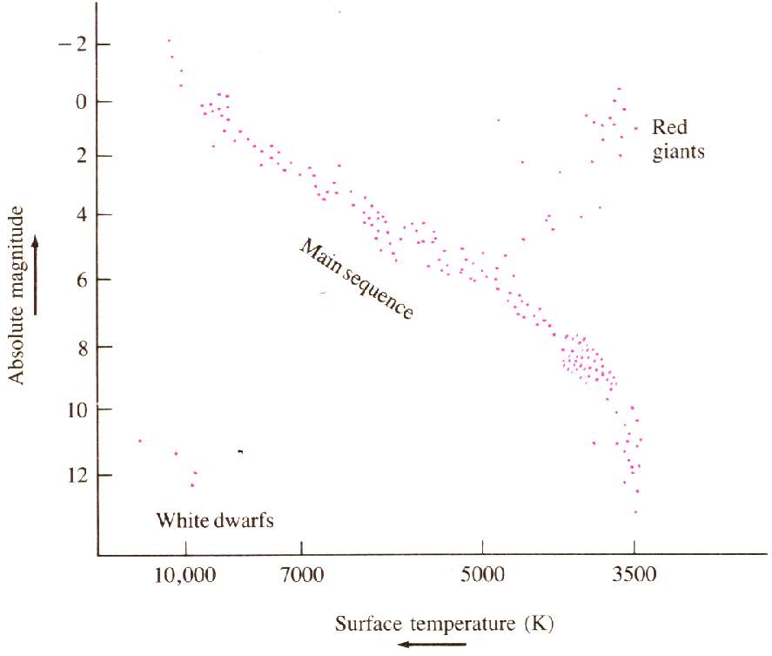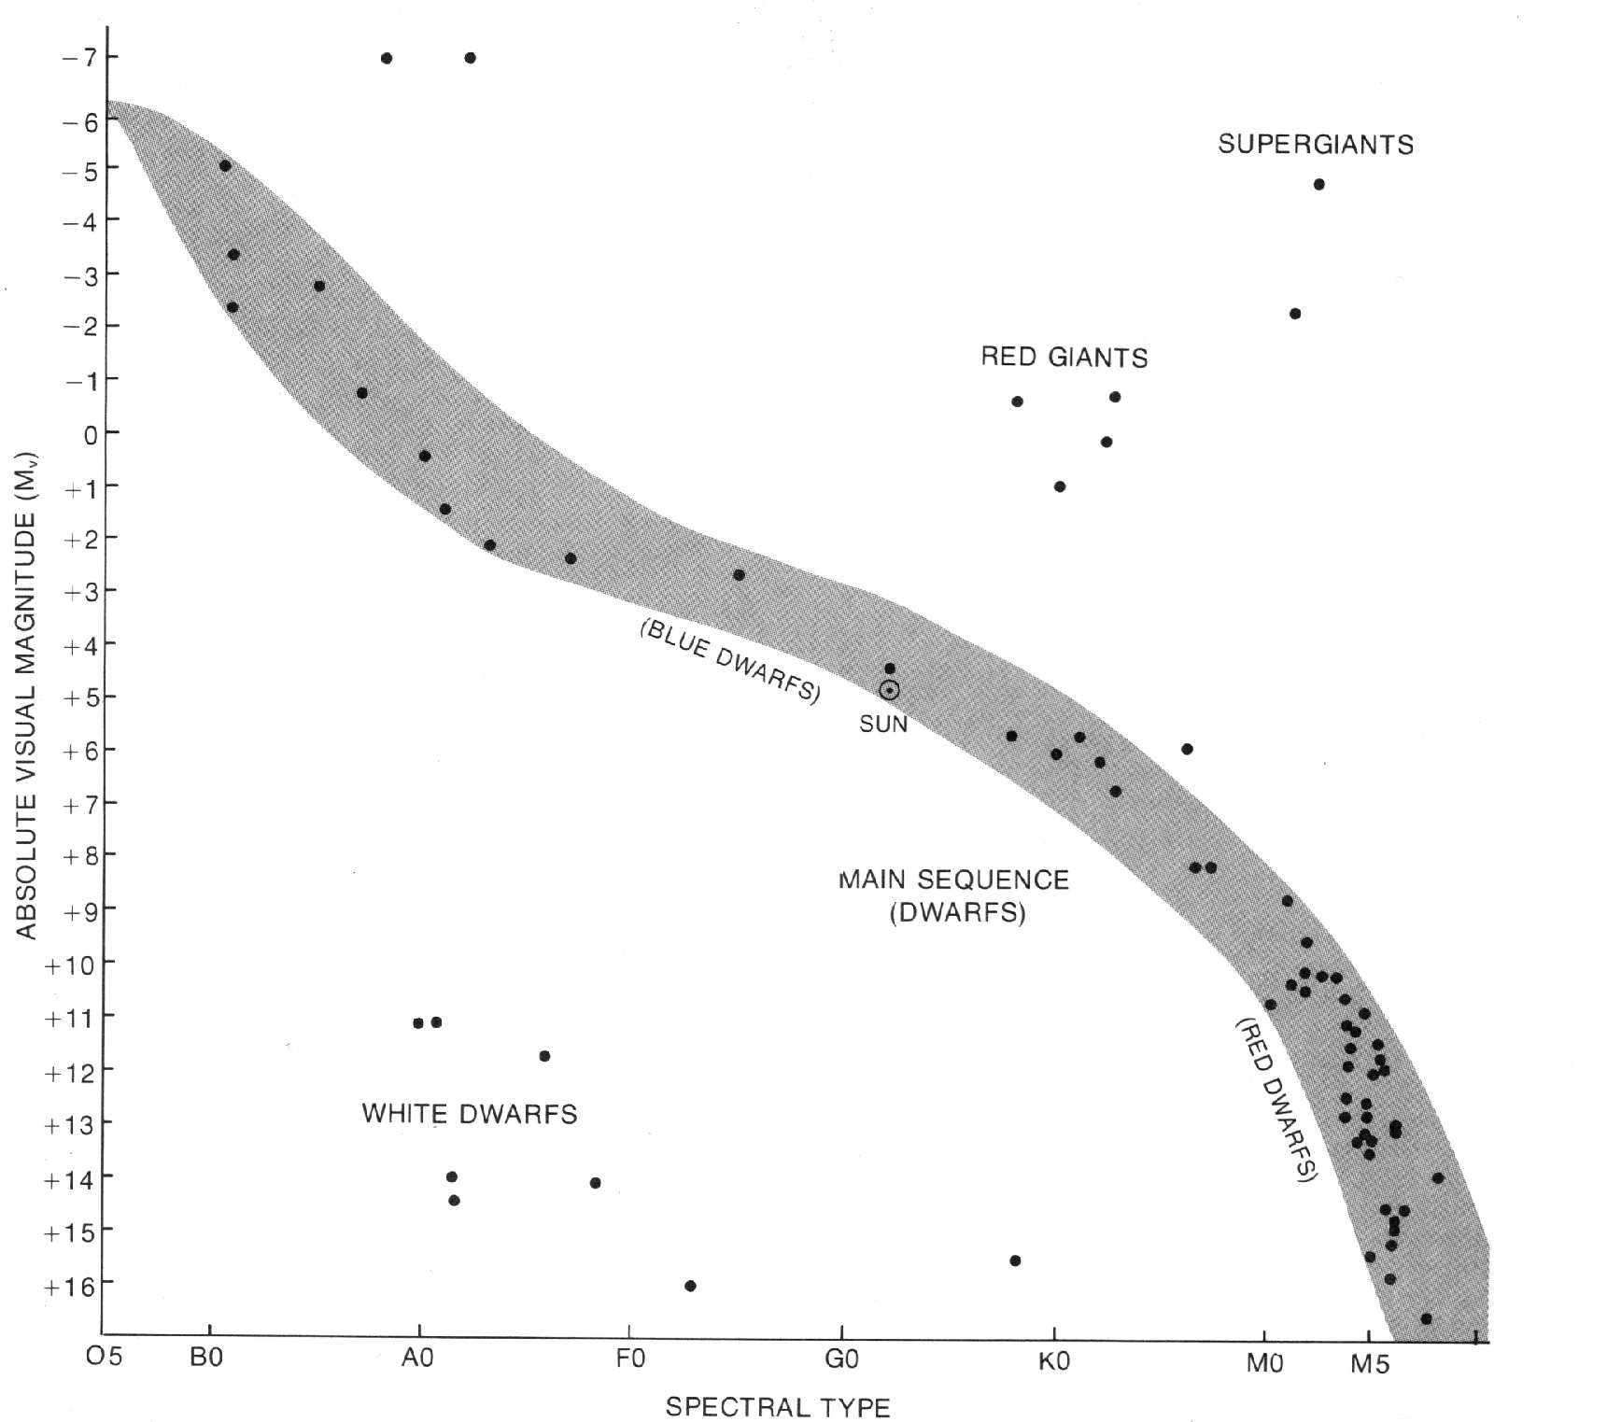

Example: How far is a B0 that has an m of 8?

Hot stars are:  Big, Bright, Brief and Blue  Cool stars are:  Diminuitive, Dim, and Durable and um… reD | (Oh Be A Fine Girl Kiss Me)  Spectral Types  O – 30,000 - 60,000 K, ionized H, weak H lines, spectral lines are  spread out. O types are rare and gigantic.  B – 10,000 - 30,000K, H lines are stronger, lines are less spread out  (Rigel, Spica are type B stars)  A – 7,500 - 10,000K, strong H lines, Mg, Ca lines appear (H and K) (Sirius, Deneb and Vega are A type stars)  F – 6,000 - 7,500K, weaker H lines than in type A, strong Ca lines  (Canopus (S.H.) and Polaris are type F)  G – 5,000 - 6,000K, yellow stars like the sun. Strongest H and K  lines of Ca appear in this star.  K – 3,500 - 5,000K, spectrum has many lines from neutral metals.  Reddish stars (Arcturus and Aldebaran are type K stars)  M - 3,500 or less, molecular spectra appear. Titanium oxide lines  appear. Red stars (Betelgeuse is a prominent type M)  Suffixes 0 (hottest) - 9 (coolest) so O0, O1…O9, then B0, B1…

