New Flowchart of stellar Evolution!
(Go to the website, click on the links, and answer the questions in the margins)
http://www.astro.washington.edu/courses/astro211/Lectures/stellar_evolution.html
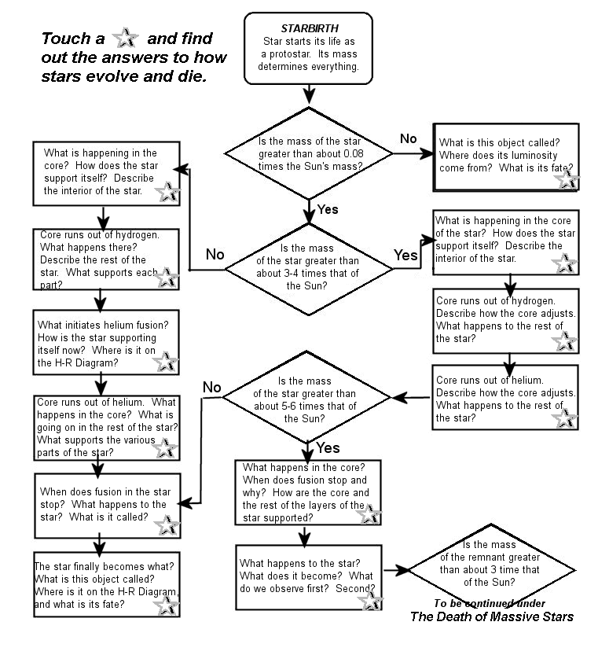
(Turn Over)

