Noteguide for Basic Magnetism - Video 20A Name
Definition of N and S poles

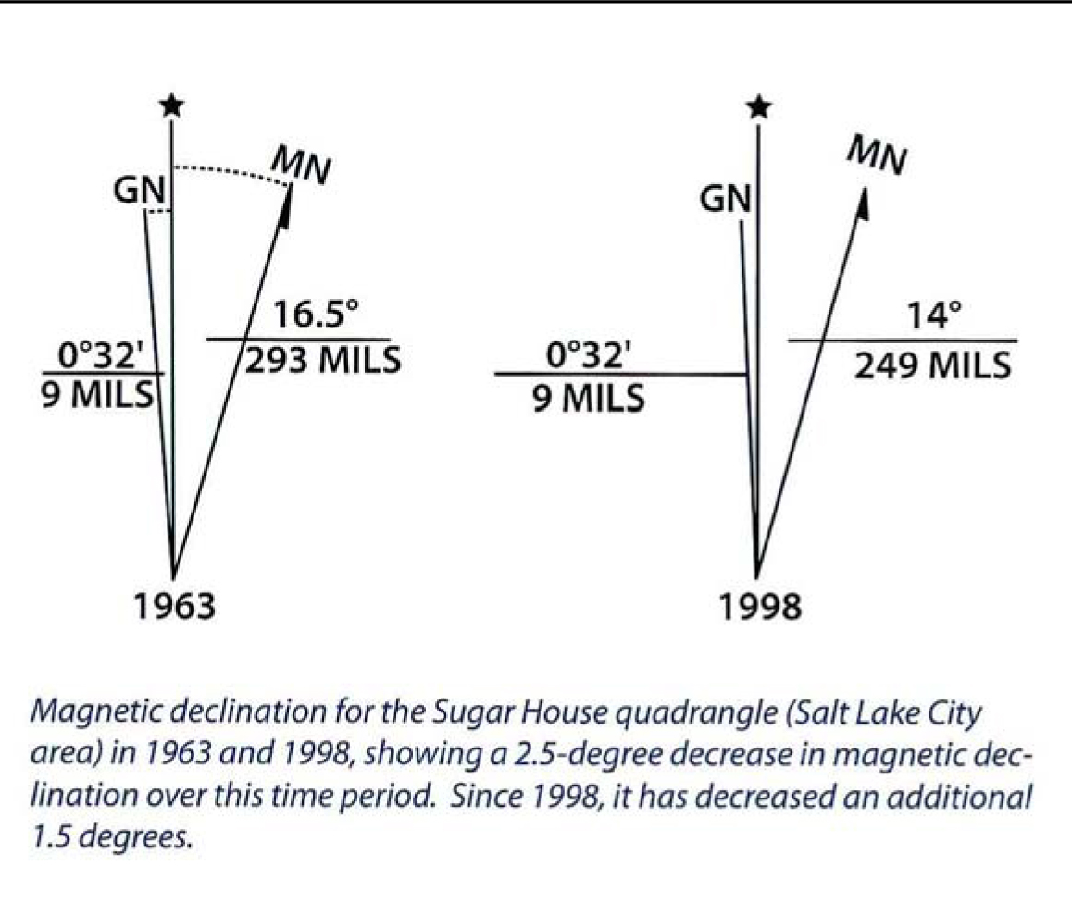
Finding polarity of a magnet

Shocking revelation

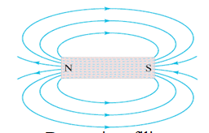

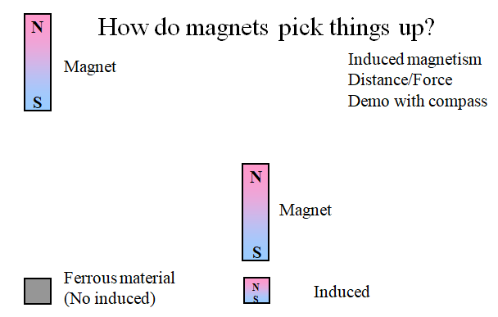

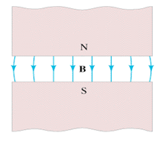

Remember – B Field Lines:
- Leave the N pole
- Enter the S pole

Right Hand Rule #1 - Magnetic Fields encircle wires:

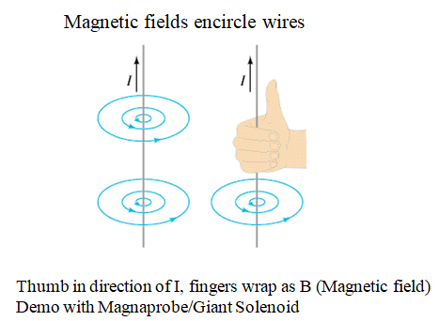

Right Hand Rule #2 - Loops of Wire act as magnets with a N and S pole:

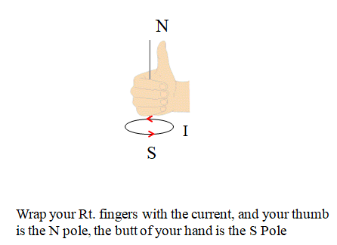

Right Hand Rule #3 - Magnetic Fields exert a force on Current Carrying wires that is perpendicular to both the Magnetic Field, and the Current:

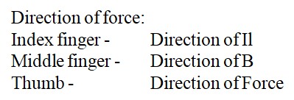

Noteguide for Force on Current-Carrying Wires - Videos 20B Name

Example: A 0.15 T magnetic field is 27º east of North What’s the force on a 3.2 m long wire if the current is 5.0 A to the West?
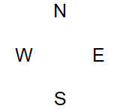

Whiteboards
1. What current in what direction would you need to have a force of 10.0 N to the west in 50.0 cm of wire perpendicular to Earth’s magnetic field of  0.5 x 10⁻⁴ T to the North? (4 x 10⁵ A upward) | 2. A 17 cm wire forms a 37º angle with an unknown magnetic field. What is the magnetic field if the force equals 0.015 N and I = 5.0 A?  (2.9 x 10⁻² T)
3. 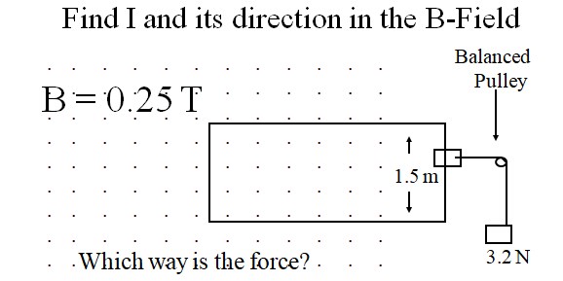  (8.5 A, ACW) | 4. 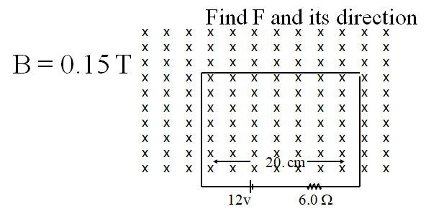  (0.060 N, Up)

Noteguide for Particles in a Magnetic Field - Videos 20C Name

Recall
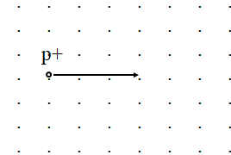
F = IlBsinθ
Derive
F = qvBsinθ
  - F = force on moving particle
  - q = charge on particle (in C) (+ or -???)
  - v = particle’s velocity
  - θ = angle twixt v and B
Whiteboards
1. What is the force acting on a proton moving at 2.5 x 10⁸ m/s to the North in a 0.35 T magnetic field to the East? (1.4 x 10⁻¹¹ N, Downward)  q = 1.602 x 10⁻¹⁹ C | 2. What magnetic field would exert 1.2 x 10⁻¹² N on an alpha particle going 17% the speed of light?  alpha = 2p2n (0.073 T)  q = 2(1.602 x 10⁻¹⁹ C) = 3.204 x 10⁻¹⁹ C  v = 0.17x3.00 x 10⁸ m/s = 5.1 x 10⁷ m/s

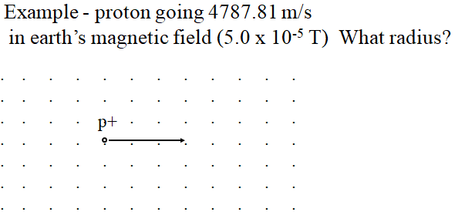

Whiteboards
1. If the electron is going 1.75 x 10⁶m/s, and the magnetic field is .00013 T, what is the radius of the path of the electron? (7.7 cm)  m = 9.11 x 10⁻³¹ kg  q = 1.602 x 10⁻¹⁹ C | 2. What B-Field do you need to make a proton going 2.13 x 10⁷ m/s go in a 3.2 cm radius circle ACW in the plane of this page? (7.0 T into the page)  m = 1.673 x 10⁻²⁷ kg  q = 1.602 x 10⁻¹⁹ C

Whiteboards: (Try to predict the direction they curve - remember electrons go opposite)
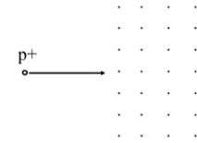 |  | 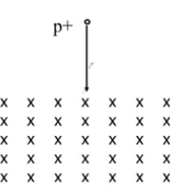
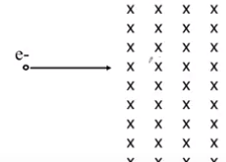 | 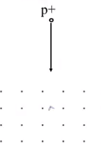

Particle Accelerators:
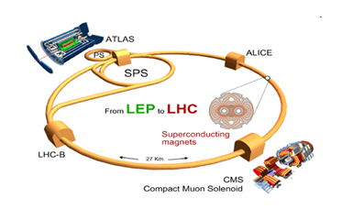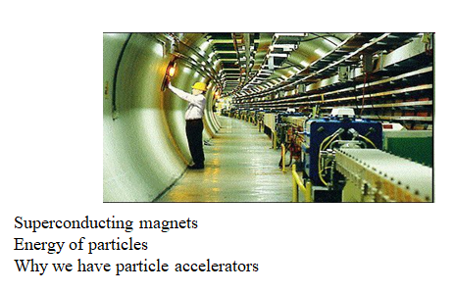

The Aurora Borealis: (Northern Lights)
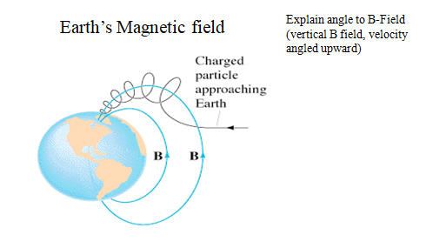

Noteguide for Crossed Fields and Mass Spec - Videos 20D Name

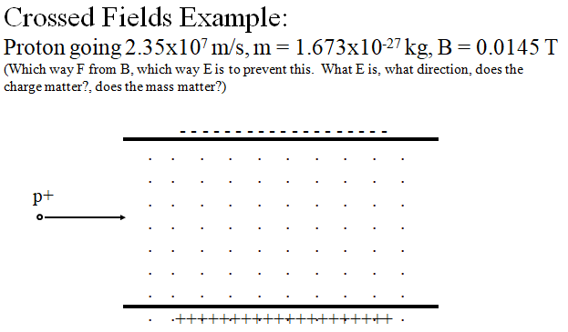

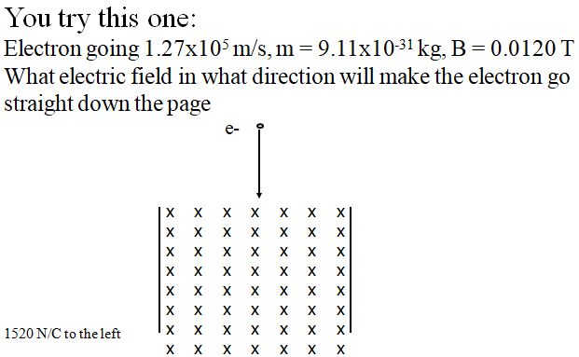

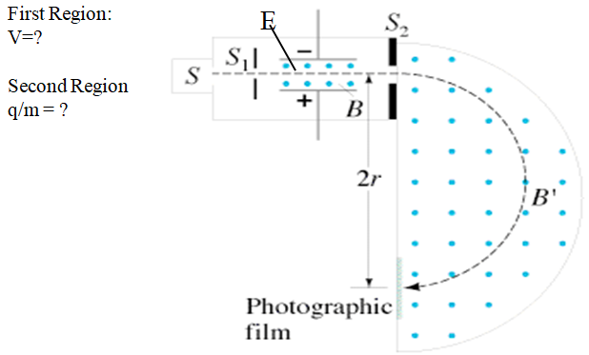

Noteguide for The Hall Effect - Videos 20E Name

Two Possible Scenarios:

Positive Charge Carriers in wire: (incorrect)  Conventional Current is to the right  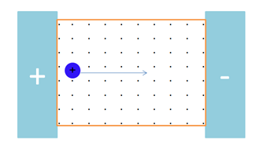 | Negative Charge Carriers in wire: (correct)  Conventional Current is to the right  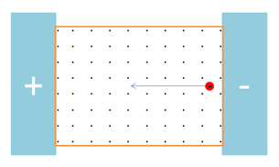

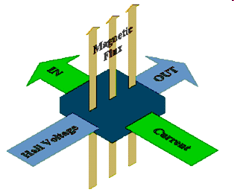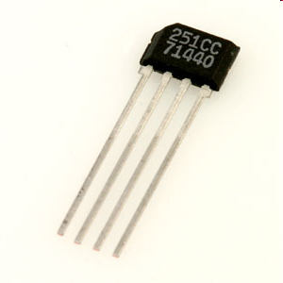

Noteguide for Hysteresis and Magnetization - Videos 20F Name

Freakin' magnets, how do they work?
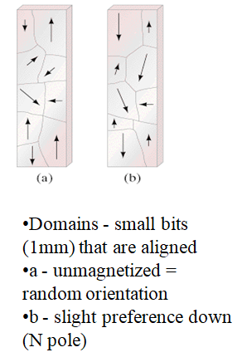

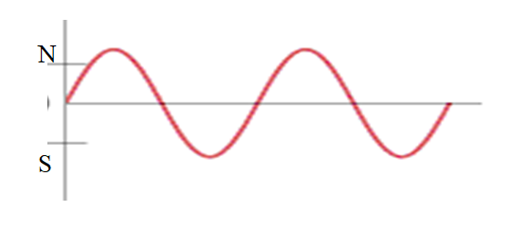

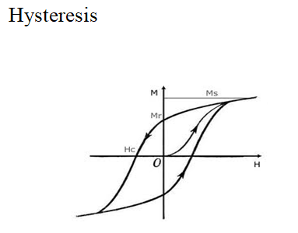

Noteguide for Motors, Galvanometers, and Speakers - Videos 20G Name

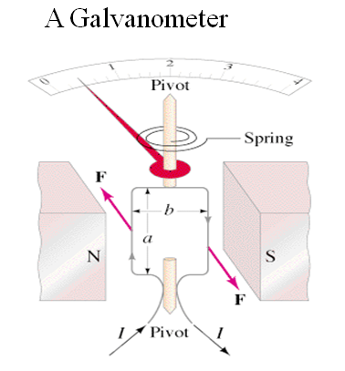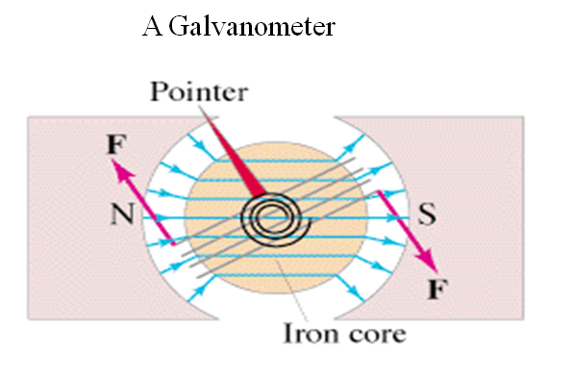

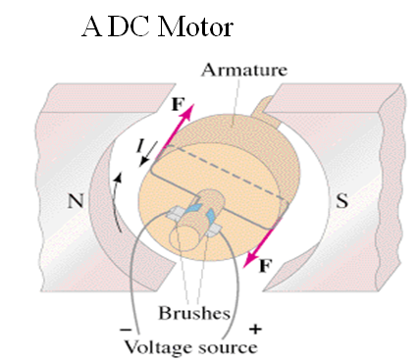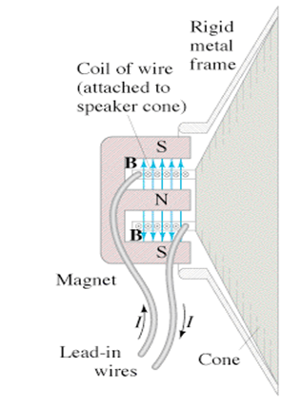

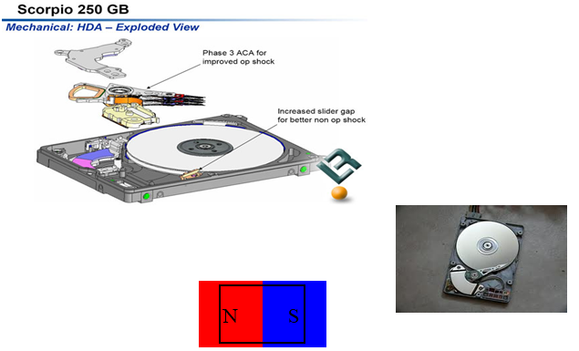

Noteguide for Ampere's Law - Videos 20H Name

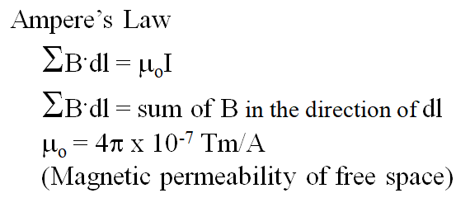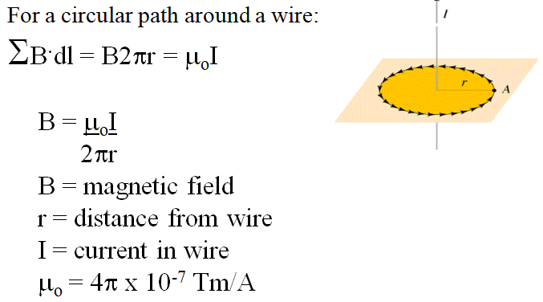

Whiteboards:
1. What is the magnetic field 13 cm from a wire that is carrying 45 A? (6.9x10⁻⁵ T) | 2. At what distance from a wire carrying 1.20 A is the magnetic field 1.50 x 10⁻⁴ T? (1.6x10⁻³ m )
3. If a wire has a magnetic field of 1.15 x 10⁻⁴ T at a distance of 2.51 cm from its center, what is the current flowing in the wire? (14.4 A)

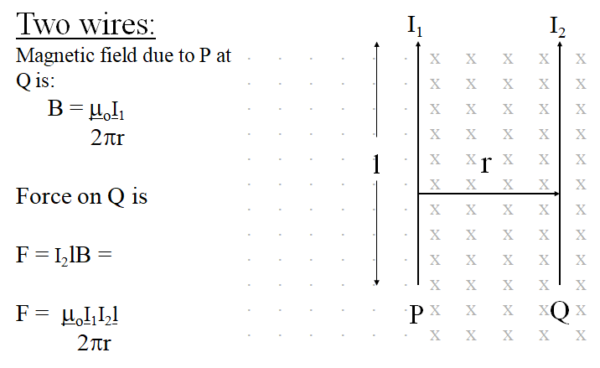
Whiteboards:
1. 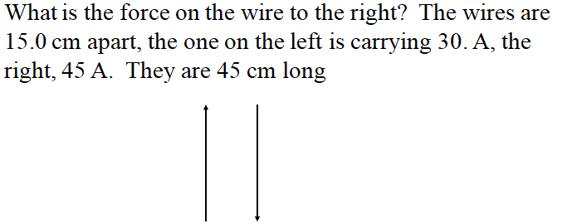  (8.1x10⁻⁴ N to the right) | 2. 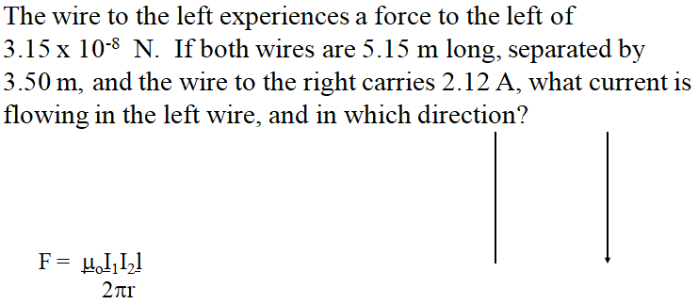  (5.05x10⁻² A up the page)
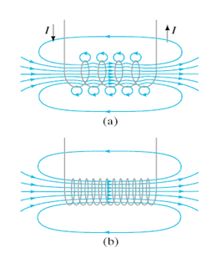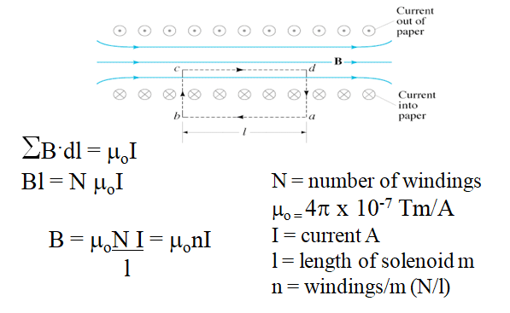

Whiteboards:
1. A solenoid has 360 windings. It is 13 cm long, and carries a current of 1.75 A. What is its internal B-Field? (0.0061 T) | 2. A solenoid needs to generate 1.0 T of B-field. it is 20 cm long, and has 100. windings. What current does it need? (1600 A)

Noteguide for The Definition of the Ampere - Video 20I Name

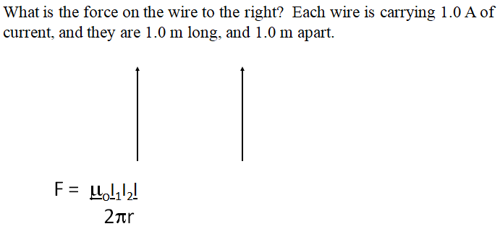

Definition of an ampere:
An ampere is defined as the current flowing in each of two long, straight and parallel wires exactly one meter apart so that there is a force of exactly 2 x 10⁻⁷ N per meter of length acting on the wires.
(A coulomb is an Amp Second)

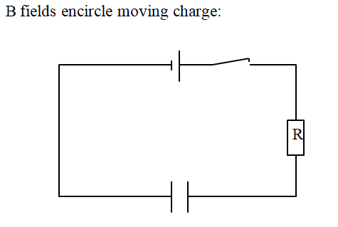

Noteguide for Basic Field Patterns - Video 20K Name

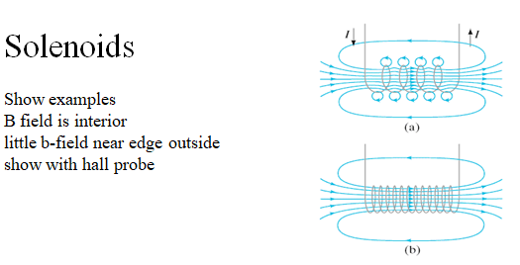

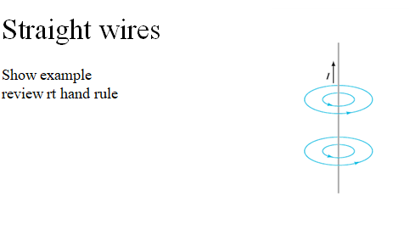

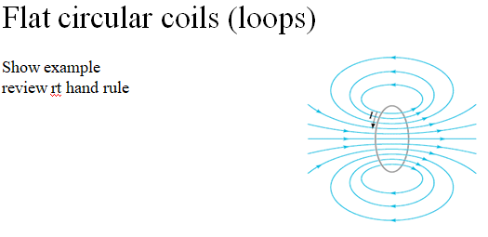

Noteguide for Lenz's Law - Video 21A Name
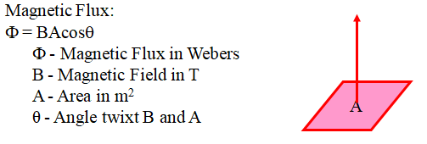
For now, think of magnetic flux as the magnetic field multiplied by the area.
Lenz's Law states that if the flux in a loop of wire changes, it will induce a current whose flux opposes that change. Watch the videos so that you understand:

1. The direction of the flux caused by the current in a loop:
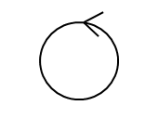 | 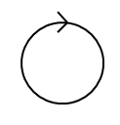 | 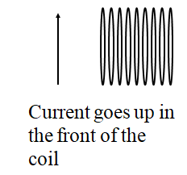
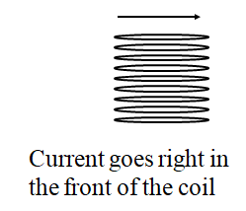 | 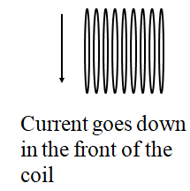 | 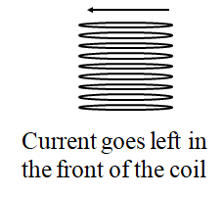

2. The direction the current flows in the loop or solenoid due to a change in flux: (three steps)
Find the direction of the change of flux. Are you gaining or losing flux, and which way is it?
a. If you are gaining flux, the current flows to oppose the change.
b. If you are losing flux, the current flows to replace the lost flux.
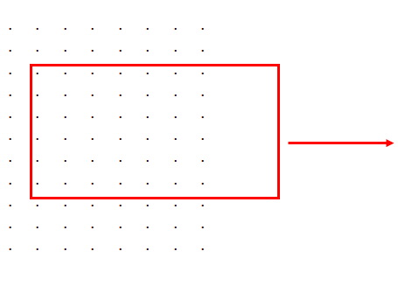 |  | 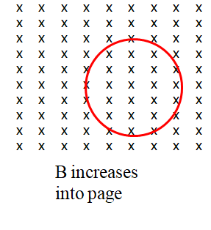 | 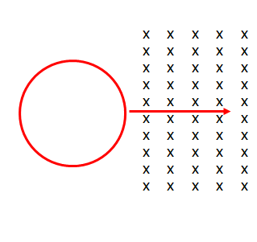
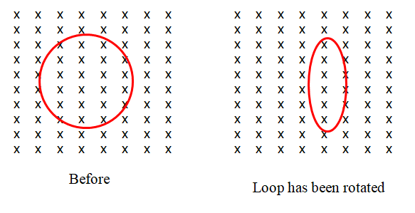 |  | 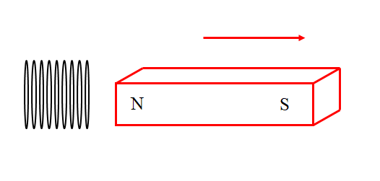
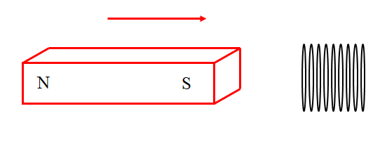 |  | 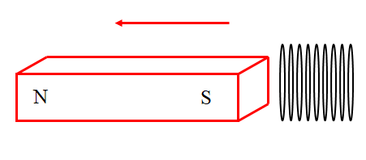
(more on the back)

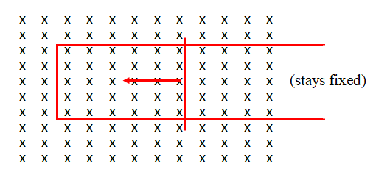 |  | 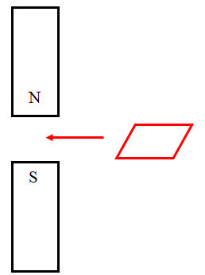 | 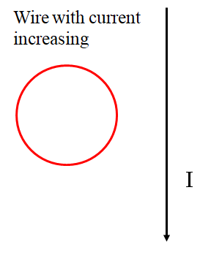
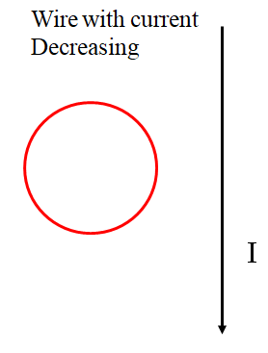 | ?????
 | 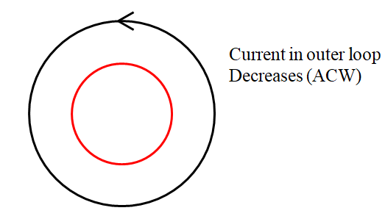 |  | 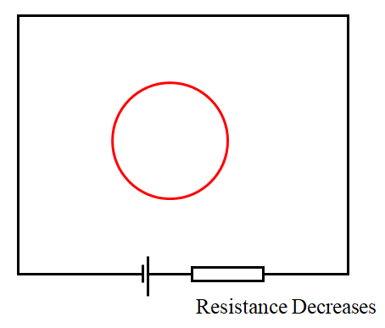

Noteguide for Faraday's Law - Videos 21B Name

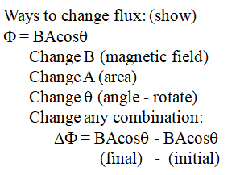

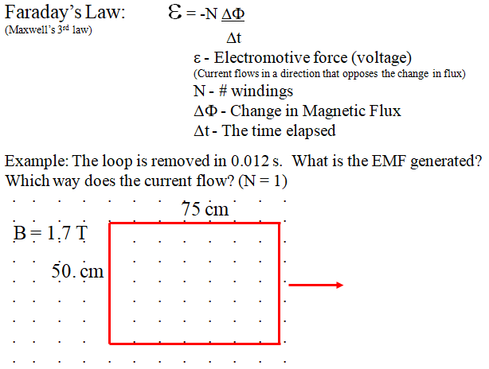

Whiteboards:
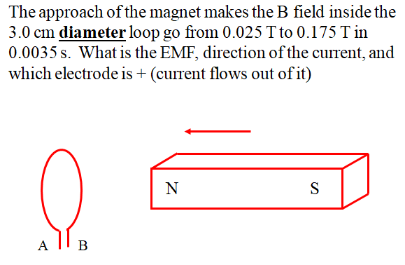  (0.030 V, ACW, A is +) | 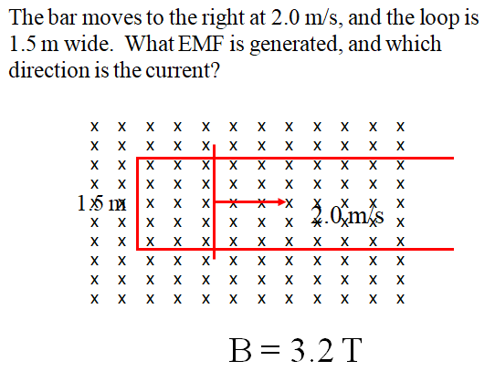  (9.6 V, ACW)
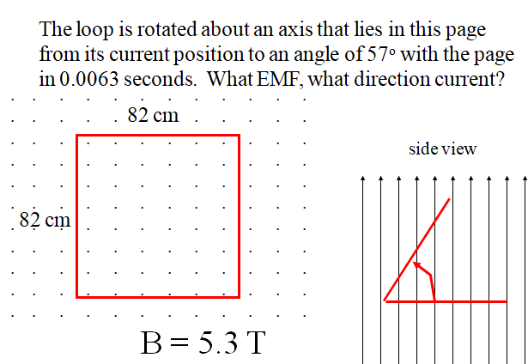
(260 V, ACW)

Noteguide for Moving Conductors - Videos 21C Name
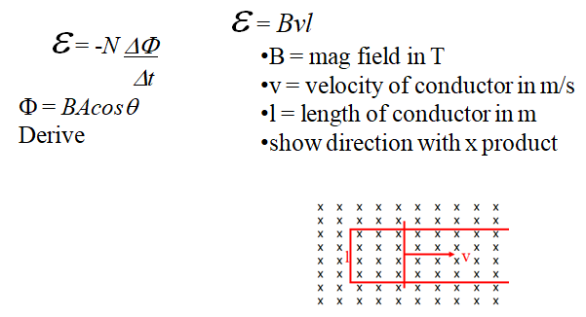

Whiteboards:
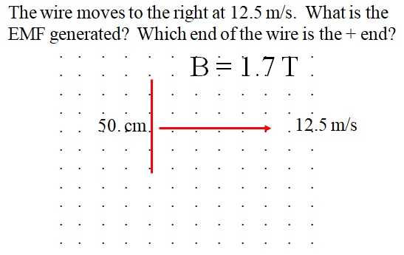  (11 V, bottom is +) | 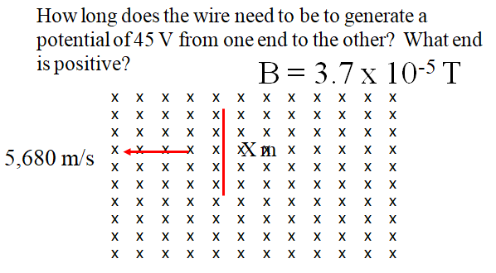  (210 m, bottom is +)
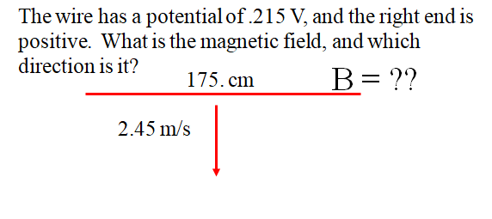  (0.0501 T ,into page) | this space for rent

If the moving conductor is not just a wire, but a sheet of conducting material, this gets more interesting. Currents are induced by changing flux. We can talk about this in class next time. I have demos.

Noteguide for Alternators - Video 21D Name
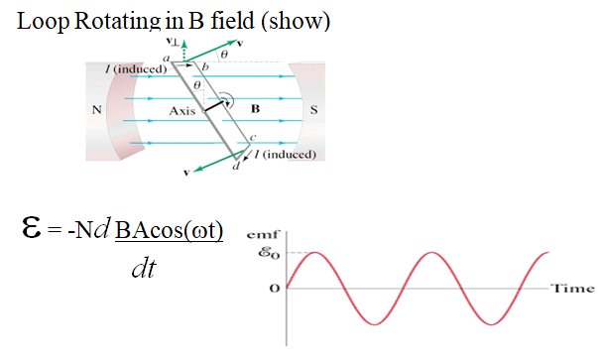

Solution for ε:

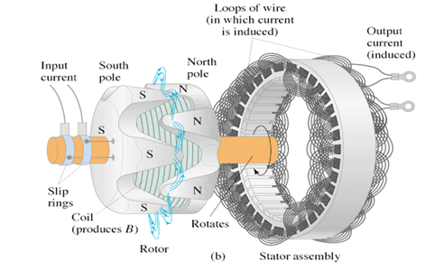

Noteguide for Transformers - Videos 21E Name
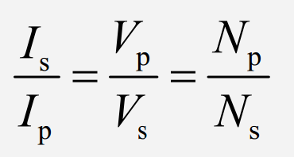
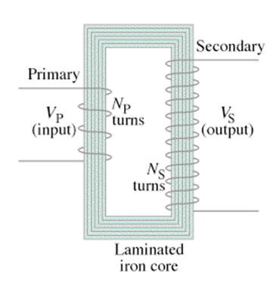
Example: A transformer has 120 primary windings, and 1450 secondary. If there is an AC voltage of 15 V, and a current of 350 mA on the primary, what is the current and voltage on the secondary?

Whiteboards:
1. A transformer has 120 primary windings, and 2400 secondary windings. If there is an AC voltage of 90. V , and a current of 125 mA in the primary, what is the voltage across and current through the secondary? (1800 V, 6.25 mA) | 2. A transformer is operating at 12.5 W. It steps 110 VAC down to 9.6 VAC. There are 320 primary windings.  A) How many secondary windings are there?  B) What is the current in the primary and secondary?  (28 windings, 0.11 A, 1.3 A)
3. An AC Arc welder can deliver 550 Amps of current. If it draws 18 amps from the wall at 120 VAC, what is the delivered voltage? If the primary has 1200 windings, how many does the secondary have? (3.9 V, 39)

Noteguide for Power Transmission - Videos 21F Name
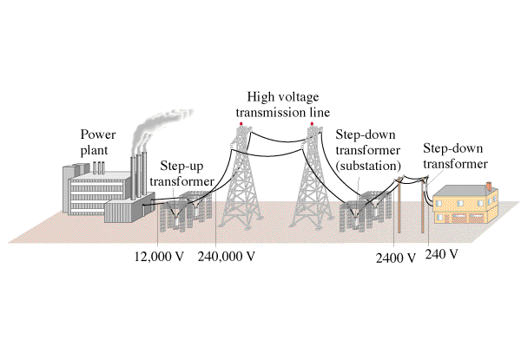
Example:
If you transmit 1000. W at 120 V on wires that have a resistance of 2.0 ohms, what power is lost?

If you transmit 1000. W at 12,000 0V on wires that have a resistance of 2.0 ohms, what power is lost?

Whiteboards:
1. If you transmit 1300. W of power at 600. VAC, how much power is lost if the lines have a resistance of 1.70 Ω? (7.98 W ) | 2. If you wanted to transmit 7800. W of power over 5.20 Ω power lines, what voltage would you need to use to waste only 6.30 W?  (7086 V)
3. You transmit 23,000. W of power at 19,300 VAC and waste only 8.20 W. What is the resistance of your transmission lines?  (5.77 Ω) | 4. You are wasting 9.50 W of power, when you transmit at 32,400 VAC on 2.30 Ω transmission lines. What is your transmitted power? (65,848 W)

Noteguide for Maxwell's Equations - Video 21G Name
