Noteguide for Power Transmission - Videos 21F Name
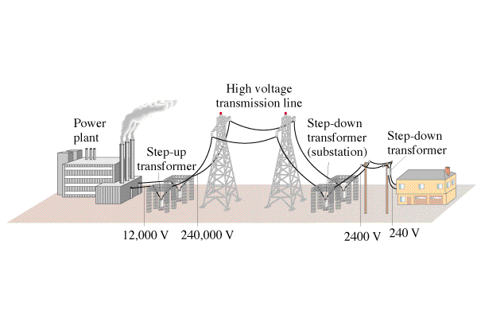
Example:
If you transmit 1000. W at 120 V on wires that have a resistance of 2.0 ohms, what power is lost?

If you transmit 1000. W at 12,000 0V on wires that have a resistance of 2.0 ohms, what power is lost?

Whiteboards:
1. If you transmit 1300. W of power at 600. VAC, how much power is lost if the lines have a resistance of 1.70 Ω? (7.98 W ) | 2. If you wanted to transmit 7800. W of power over 5.20 Ω power lines, what voltage would you need to use to waste only 6.30 W?  (7086 V)
3. You transmit 23,000. W of power at 19,300 VAC and waste only 8.20 W. What is the resistance of your transmission lines?  (5.77 Ω) | 4. You are wasting 9.50 W of power, when you transmit at 32,400 VAC on 2.30 Ω transmission lines. What is your transmitted power? (65,848 W)

