Noteguide for Alternators - Video 21D Name
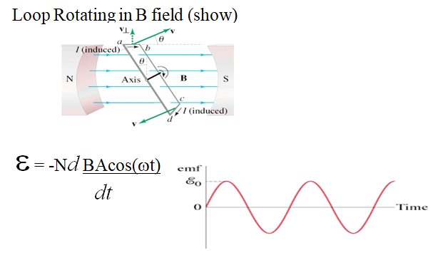

Solution for ε:

