Noteguide for Moving Conductors - Videos 21C Name
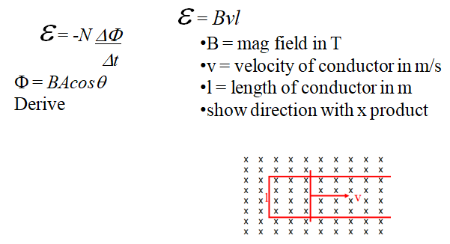

Whiteboards:
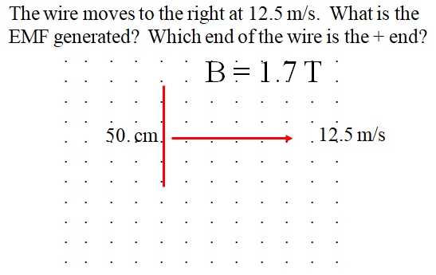  (11 V, bottom is +) | 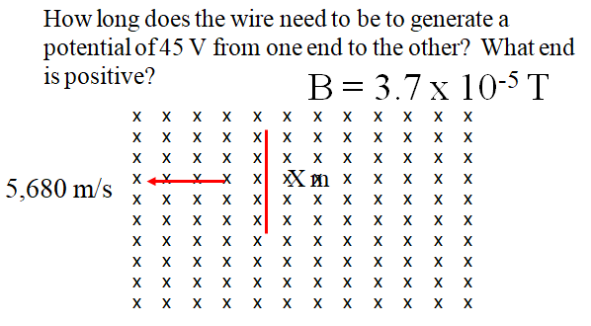  (210 m, bottom is +)
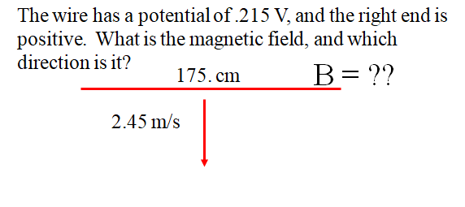  (0.0501 T ,into page) | this space for rent

If the moving conductor is not just a wire, but a sheet of conducting material, this gets more interesting. Currents are induced by changing flux. We can talk about this in class next time. I have demos.

