**Noteguide for Faraday's Law - Videos 21B Name**

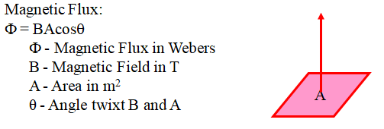 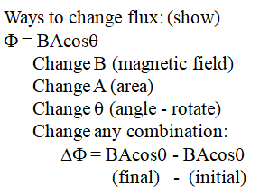

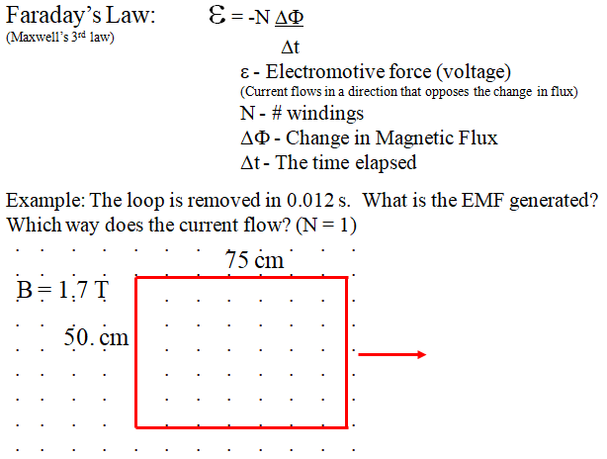

Whiteboards:

|  |  |
| --- | --- |
| (0.030 V, ACW, A is +) | (9.6 V, ACW) |
| (260 V, ACW) |  |