**Noteguide for Lenz's Law - Video 21A Name**

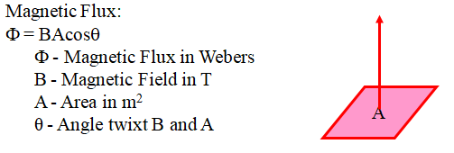

For now, think of magnetic flux as the magnetic field multiplied by the area.

**Lenz's Law states that if the flux in a loop of wire changes, it will induce a current whose flux opposes that change. Watch the videos so that you understand:**

1. The direction of the flux caused by the current in a loop:

|  |  |  |
| --- | --- | --- |
|  |  |  |
|  |  |  |

2. The direction the current flows in the loop or solenoid due to a change in flux: (three steps)

Find the direction of the change of flux. Are you gaining or losing flux, and which way is it?

a. If you are gaining flux, the current flows to **oppose** the change.

b. If you are losing flux, the current flows to **replace** the lost flux.

|  |  |  |  |
| --- | --- | --- | --- |
|  |  |  |  |
|  | |  | |
|  | |  | |

(more on the back)

|  |  |  |  |
| --- | --- | --- | --- |
|  | |  |  |
|  | ????? |
|  | |  |