Noteguide for Basic Magnetism - Video 20A Name
Definition of N and S poles

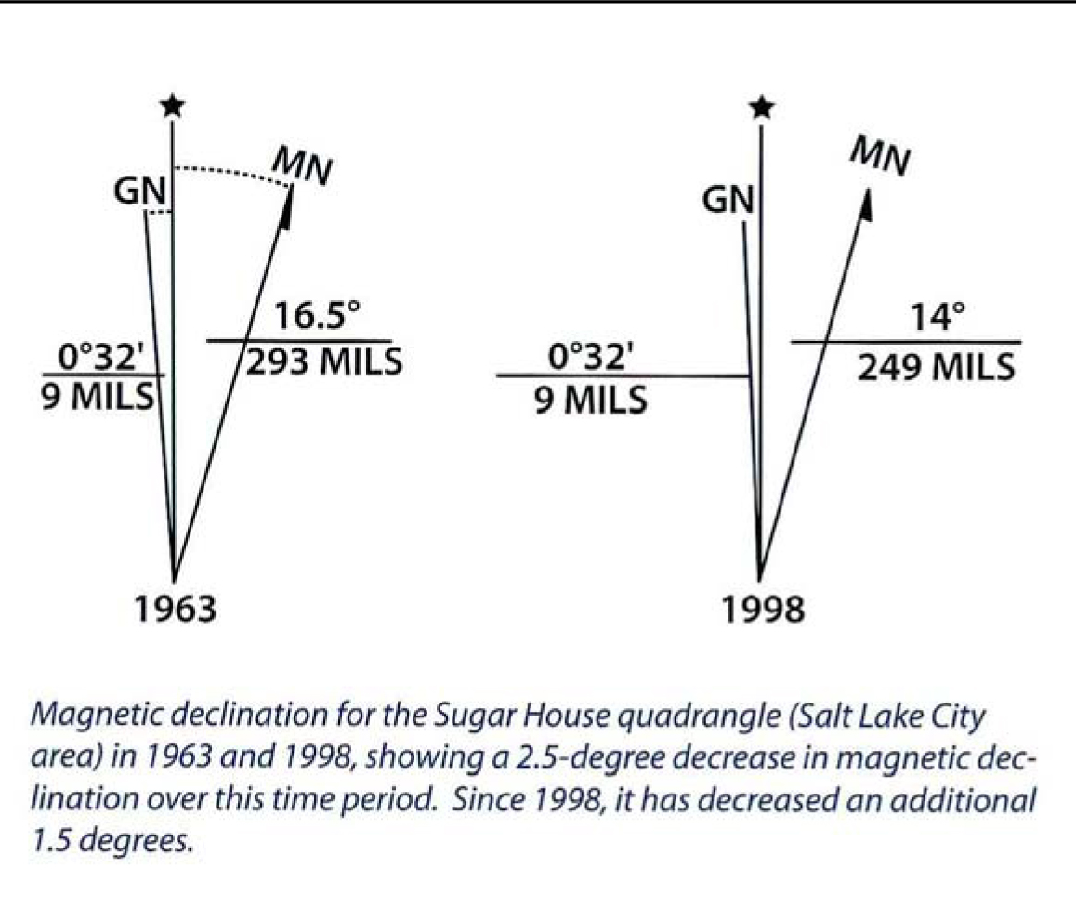
Finding polarity of a magnet

Shocking revelation

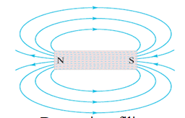

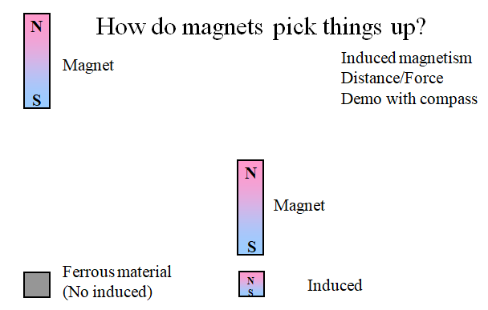

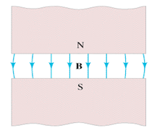

Remember – B Field Lines:
- Leave the N pole
- Enter the S pole

Right Hand Rule #1 - Magnetic Fields encircle wires:

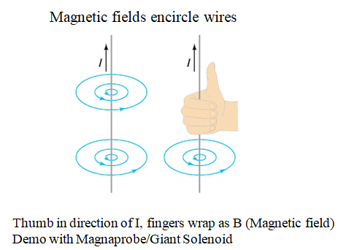

Right Hand Rule #2 - Loops of Wire act as magnets with a N and S pole:

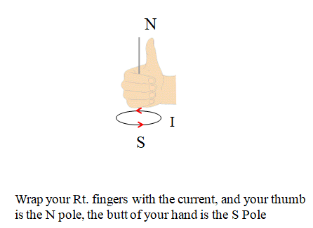

Right Hand Rule #3 - Magnetic Fields exert a force on Current Carrying wires that is perpendicular to both the Magnetic Field, and the Current:

