IB Magnetism Mock Test

1. An electron goes in clockwise in a 0.00115 m radius circle in the plane of this page. It has a velocity of 1.60x10⁶ m s⁻¹.
a. Draw the velocity, magnetic force, and acceleration vectors. Calculate the magnetic field, state the direction. (7.91 mT, into page)
b. Show that the magnetic field is given by $B= \frac{mv}{er}$ where m is the electron mass, v the velocity, e the elementary, r the radius
c. Show that the period T of its motion is given by $T= \frac{2πm}{eB}$ where etc.
d. What is the relationship between the velocity of the electron and its radius r of curvature? How does mass affect r? How does B affect r?
(Increasing v increases r, increasing m increases r, increasing B decreases r)

2. A negatively charged ion traveling at 1.90x10⁵ m/s is moving with a purely horizontal velocity between two parallel plates separated by 5.00 cm. The top plate is at a positive potential of 250. V, and the bottom plate is at 0 V.
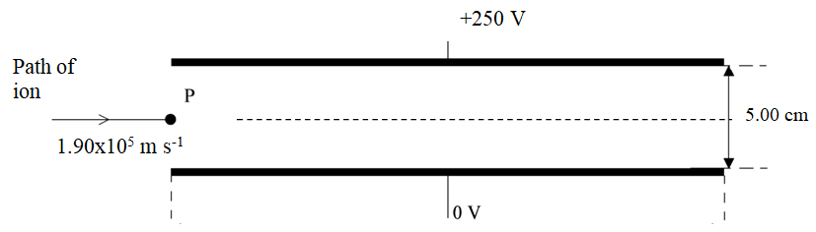
a. Calculate the electric field between the plates. Indicate the direction of the electric force. (5000 V/m down, upwards)
b. The plates are now placed in a magnetic field so that the ion goes straight. Calculate the magnitude and direction of the field. (26.3 mT into page)
c. Determine how increasing the following would deflect the ion (up, down, not deflected) : Ion velocity, ion mass, ion charge, magnetic field, potential across the plates. (v:down, m:not, q:not, B:down, V:up)

3. A rectangular wire loop with a resistance of 0.215 Ω starts outside a magnetic field perpendicular to this page and is pulled at a constant velocity of 11.0 m/s until it is entirely inside the magnetic field.
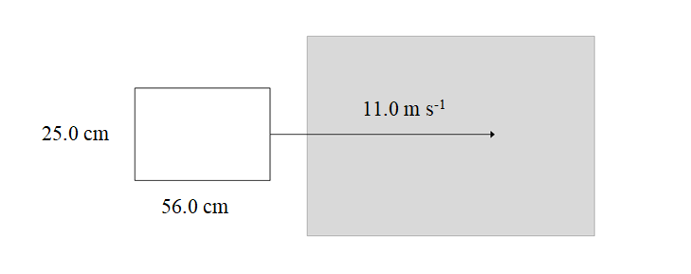
a. Explain why there is an induced EMF in the coil. Explain when the EMF begins to be induced, and exactly when it ends. If the EMF makes the current in the loop go anti-clockwise as it enters the field, is the magnetic field out of or into the page? (B is into page)
b. As the loop enters the magnetic field, there is a force opposing its motion. Explain the origin of this force.
c. The induced EMF in the loop is 6.20 V. Calculate the current that flows and the magnetic field strength. Calculate the force opposing the motion of the loop. Show that the magnetic field is given by $B= \frac{\sqrt{\frac{RF}{v}}}{l}$ R is the resistance of the loop, F the force, v the velocity, and l the length of the side entering the magnetic field. (28.8 A, 2.25 T, 16.3 N)

4. A datalogger is attached to a coil so that it registers a positive emf value when the current is flowing up the front of the coil. A magnet with the North pole facing to the right can move through the coil.
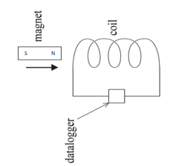
a. Explain why the motion of the magnet induces an EMF in the coil.
b. Draw a graph of how the potential changes with time as the magnet passes through at a constant speed from left to right. (positive then negative emf spike, equal in size)
c. Draw a graph of how the potential changes with time as the magnet passes through at a steadily increasing speed from left to right. (small positive, then big negative emf spike)
d. Draw a graph of how the potential changes with time as the magnet passes through at a steadily decreasing speed from left to right. (big positive, then small negative spike)
e. The coil has 500. windings and a diameter of 3.50 cm. In one instance the magnetic field goes from 0 to 312 mT to the right in 0.520 s. What is the rate change in flux in the coil? What is the induced EMF in the coil? (5.77x10⁻⁴ Webers/s, 289 mV)

5. An ideal step-up transformer steps 650. V up to a higher voltage There are 312 primary windings, and 62,400 windings on the secondary. There are 2.15 A of current in the secondary.
a. What is the voltage on the secondary? (130 kV)
b. What is the power passing through the transformer? (279.5 kW)
c. What is the current in the primary ? (430. A)
Some transmission lines have a resistance of 4.00 Ω.
d. How much power is lost if you transmit 10,000 Watts of power at 650. V? at 330. kV? (947 W, 3.67 mW)
e. Why do we laminate the cores of transformers?
f. Why do we transmit power at high voltages over long distances?

