1 Circuit Exercises (Show your work on this sheet)
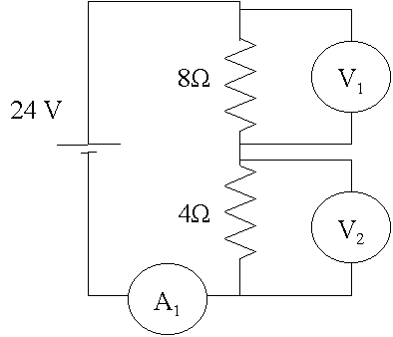
A₁: 2A
V₁: 16 V
V₂: 8V
Power _{4 Ω}: 16 W

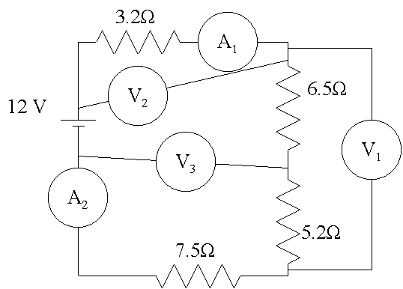
A₁: .536 A
A₂: .536 A
V₁: 6.268 V
V₂: 1.714 V
V₃: 6.804 V
Power _{6.5 Ω}:1.865 W

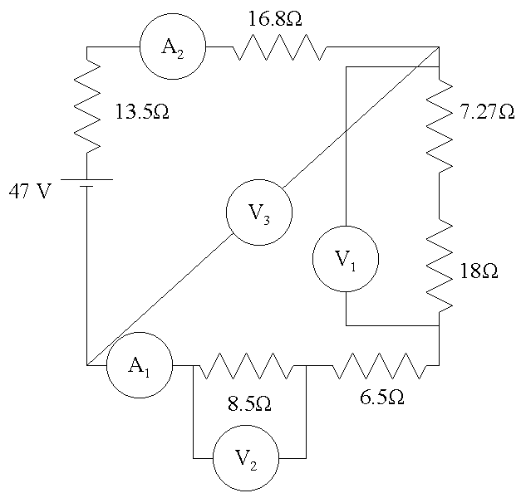
A₁: .666 A
A₂: .666 A
V₁: 16.830 V
V₂: 5.661 V
V₃: 26.820 V
Power _{13.5 Ω}:6.0 W
2
A₁: 13A
A₂: 13A
A₃: 3A
A₄: 10A
A₅: 6A
A₆: 6A
V₁: 0V
V₂: 12V
V₃: 12V
Power _{4 Ω}: 36W
A₂
A₁

A₃

V₃

V₁
V₂
A₄

A₆

12 V
4 Ω
3 Ω
A₅

2 Ω

A₃
A₂

A₁
V₁

V₂

A₁: 5.68A
A₂: 3.54A
A₃: 1.67A
V₁: 0V
V₂: 15V
8 Ω
7 Ω
9 Ω
15 V

3A
A₁: 6.323A
A₂: 2.630A
A₃: 1.333A
A₄: 1.297 A
V₁: 22.667V
13 Ω
19 Ω
17 Ω
37 Ω
48 V
V₁
A₁
A₂
A₃
A₄
3Ω Ù
5Ω Ù
7Ω Ù
11Ω Ù
13Ω Ù

17 V

V₂
A₃
V₁
V₃
A₂
A₁

A₁: .635A
A₂: .459A
A₃: 1.093A
V₁: 8.253V
V₂: 3.280V
V₃: 5.044V

3B
57.0 V
5 Ω
8 Ω
2 Ω
A₁
4 Ω

3 Ω

6 Ω

7 Ω

1 Ω

3 Ω

V₁
V₃
V₂
A₃
A₂
V₀
3.2308
10.2308
5.5225
4.5518 | A1
22.7590 | V0
25.1373 | V1
2.4570 | A2
7.9381 | V2
2.0948 | A3
8.3791 | V3
4A
7.0345
17.0345
7.3731
1.8589 | A1
5.5766 | V1
13.7057 | V2
1.0543 | A2
0.8046 | A3
5.6598 | V3
0.3329 | A4
0.4717 | A5
3.3016 | V4
23.0 V
2 Ω
6 Ω
3 Ω
7 Ω

17 Ω

5 Ω

A₁
4 Ω
13 Ω

V₂
V₁
V₃
A₂
A₄
V₄
A₅
A₃

A₁: 1.4179A
A₂: 1.9736A
A₃: .3031A
A₄: .2547A
V₁: 3.3110V
V₂: 3.0310V
V₃: 11.3432V
V₄: 5.0012V
37 V
6Ω
7Ω
11ΩΩΩ
13ΩΩ
8Ω
9Ω
10ΩΩ
12ΩΩ
A₂
V₂
V₁
V₃
V₄
A₁
A₃
A₄
4B

