Noteguide for Network Resistance - Videos 18I Name
Example 1:
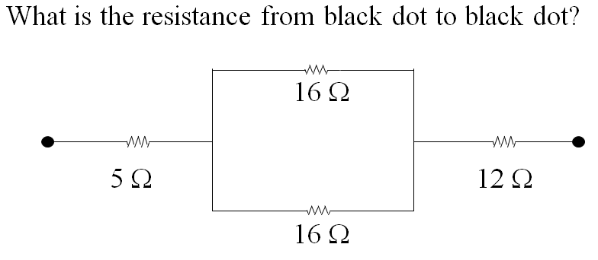

Example 2:
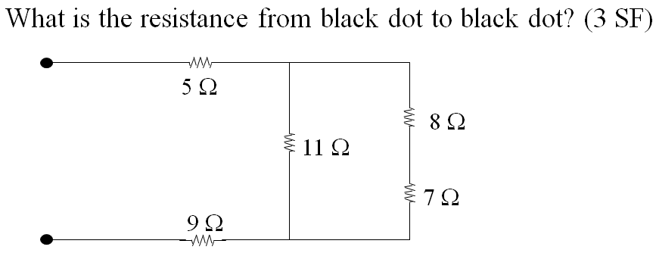

Example 3:
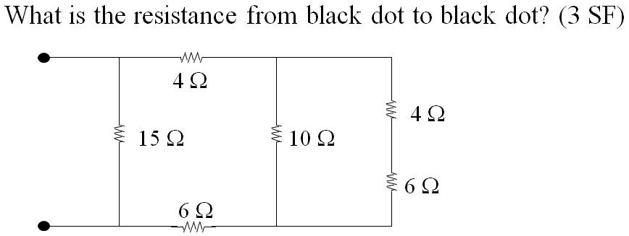

(Try the whiteboards on the back)

Try to find the resistance that is across the battery in each circuit. Ignore the Voltmeters and Ammeters for now:
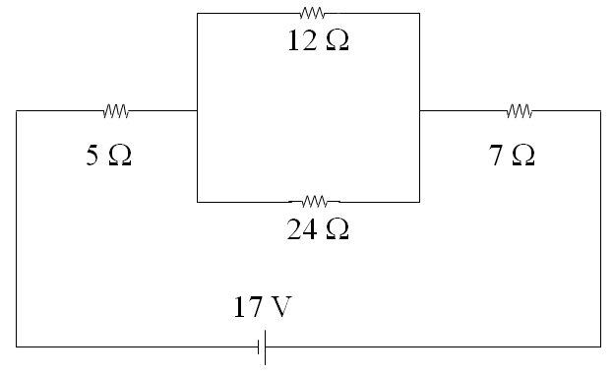(20 Ω)

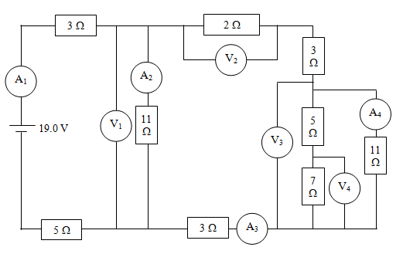(14.1 Ω)

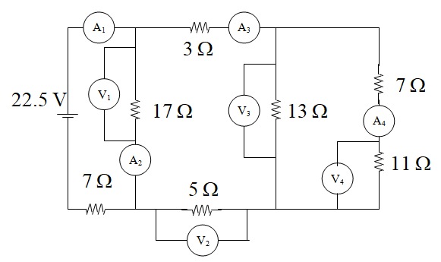(15.1 Ω)

