**Noteguide for Series and Parallel Resistance - Videos 18H Name**

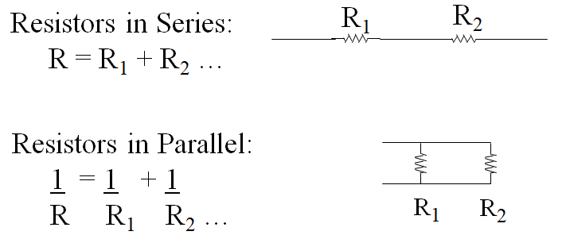 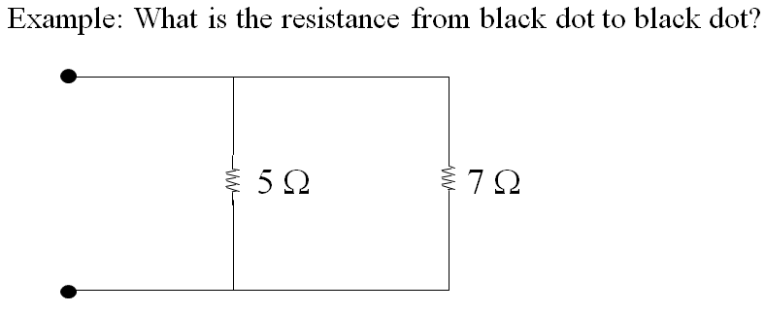

Whiteboards: (Find the resistance from the black dot to the black dot)

|  |  |
| --- | --- |
| 1. (177 Ω) | 2. (36 Ω ) |
| 3. (3.7 Ω ) | 4. ( 6 Ω ) |
| 5. (8 Ω ) | |