Noteguide for Series Circuits - Videos 18F Name

24 V
1 Ω
2 Ω
5 Ω
V₁
A₁
A₃
A₂
V₂
V₃

Try these:
(First whiteboard)
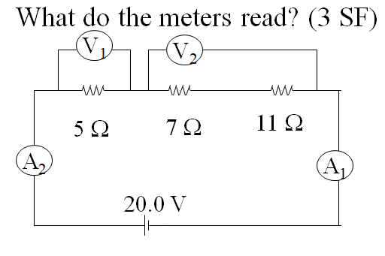
(Both Ammeters: 0.870 A, V1 = 4.35 V, V2 = 15.7 V)

(Third Whiteboard)
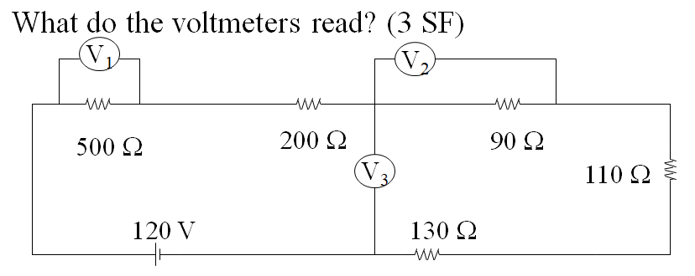
(V1 = 58.3 V, V2 = 10.5 V, V3 = 38.4 V)

