Noteguide for AC and RMS - Videos 18E Name
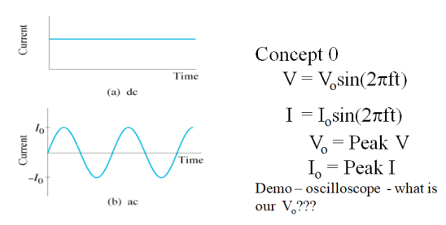
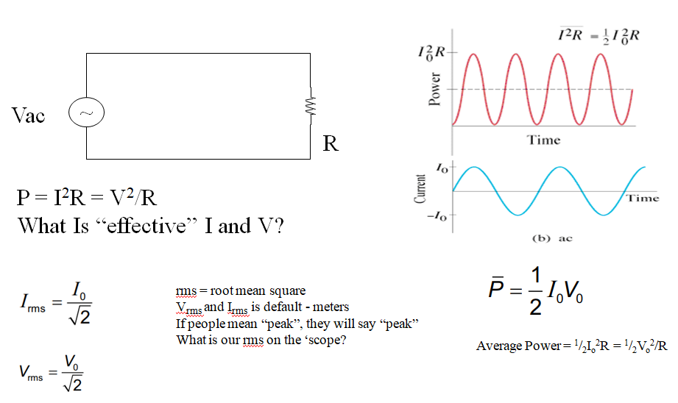

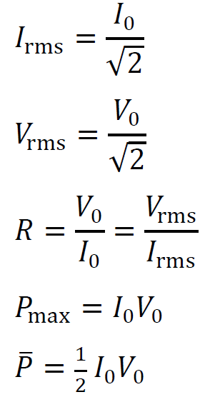

Example - A 13.50 ohm resistor has a peak voltage of 207.0 Volts across it. What is the rms voltage across it, and what is the peak and rms current through it, and the average power and peak power that it dissipates

Whiteboards:
1. What is the rms voltage if the peak voltage is 340 V? (240 V) | 2. A circuit has an rms current of 1.45 A. What is the peak current? (2.05 A)

(Do the ones on the back too)

More Whiteboards: (What a good student you are!!)
3. 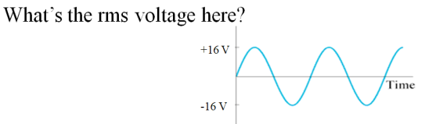 (11 V) | 4. What is the peak voltage if the rms voltage is 12 V? (17 V)
5. An 60.0 V alternating current is attached to a device that draws 3.5 amps. What is the power used? (210 W) | 6. An alternating current with a peak voltage of 18.5 V is connected to a 27.5 ohm resistor. What power is dissipated? (6.22 W)
7. A 40. Watt light is connected to a 120 Volt source. What is the peak current through the light bulb, its resistance, and what is the peak power that it dissipates? (0.47 A, 360 ohms, 80. W) | 8. A 100.2 ohm heating element is dissipating 1530 W of power. What are the peak current and peak voltage through and across the element? (find rms…) What is the peak power?  (5.5 A, 554 V, 3060 W)

