Noteguide for Electron Drift - Videos 18C2 Name

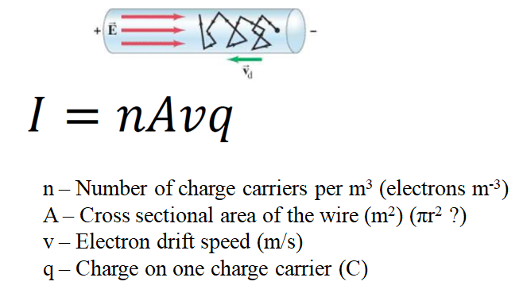

Ex #1: A 2.4 mm diameter copper (n = 8.5x10²⁸ carriers/m3) wire has a current of 5.8 amps flowing down it. What is the electron drift speed? (9.4x10⁻⁵ m/s)

Whiteboards:
1. A 1.8 mm diameter copper  (n = 8.5x10²⁸ carriers/m³) wire has an electron drift speed of 0.082 mm/s. What is the current flowing in the wire? (2.8 Amps ) | 2. A 3.4 mm wire of some material has an electron drift velocity of 0.016 mm/s when a current of 12 A flows. What is the density of charge carriers per cubic meter? (5.2x10²⁹ carriers/m³)
3. A copper (n = 8.5x10²⁸ carriers/m3) wire carrying 4.5 A has an electron drift speed of 0.13 mm/s. What is the diameter of the wire? (1.8 mm - 1.8x10⁻³ m)

