Noteguide for Resistivity - Videos 18C1 Name

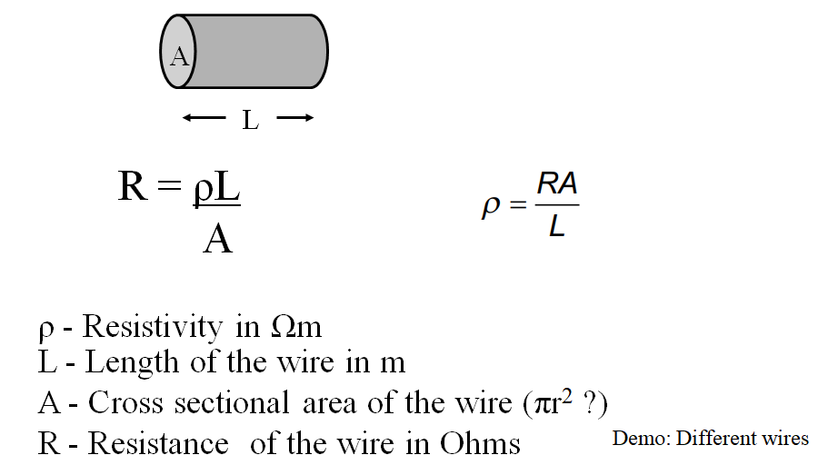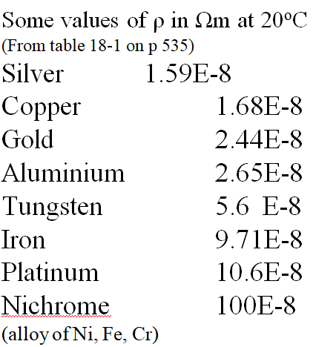

Ex #1: A steel wire is 2.7 m long, and has a resistance of 7.3 ohms. What is its diameter?

Whiteboards:
1. A copper wire is 1610 m long (1 mile) and has a cross sectional area of 4.5 x 10⁻⁶ m². What is its resistance? (This wire is about 2.4 mm in dia)  (6.0 Ω) | 2. An Aluminium wire is 3.2 mm in diameter, and has a resistance of 142 ohms. What length is it?  (43,000 m)
3. A piece of wire has a diameter of 0.42 mm, and a length of 53 cm. What is its resistivity if it has a resistance of 4.9 ohms? (what kind of wire is it?) (130x10⁻⁸ Ωm)

