Noteguide for Ohm's Law - Videos 18B Name

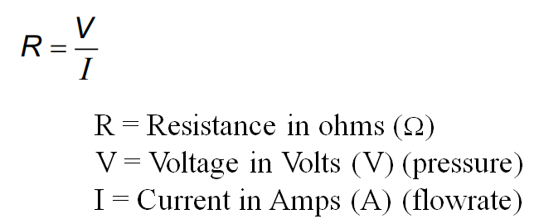
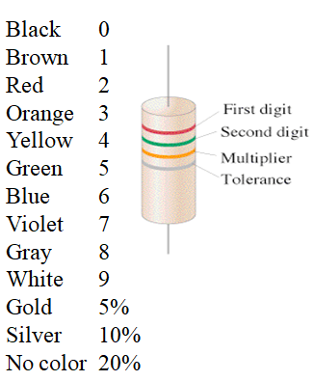

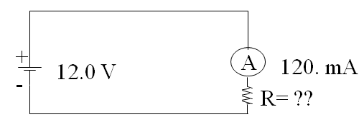
Example 1: What is the resistance in the circuit above?

Example 2: If there is a 220 Ω resistor in the circuit above, what is the current?

Whiteboards:
1. What is the resistance of a light bulb if it draws 250 mA of current from a 6.15 V battery?  (1000 mA = 1 A) (24.6 Ω ) | 2. What current will flow if you plug a paperclip with a resistance of 0.065 Ω into a 12 V source?  (180 A)
3. What voltage do you need to push 1.5 Amps of current through a 210 ohm resistor? (315 V) | 4. What current flows through an 8.1 ohm speaker when there is a voltage of 3.45 V? (0.43 A)
5. An unknown resistor draws 0.0128 Amps of current from a 23.9 V source. What is the resistance? (1870 Ω) | 6. A 1200 ohm resistor is hooked up to an unknown voltage source, and it draws 87.5 mA of current. What is the voltage? (105 V)

