Noteguide for Electrical Current - Videos 18A Name

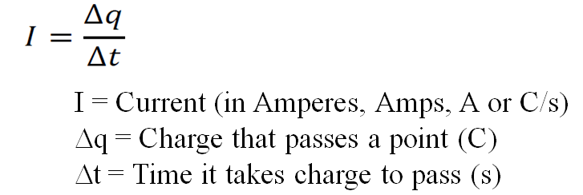

Example: What charge passes a certain point if a current of 250 mA flows for 12 minutes?

Whiteboards:
1. What is the current flowing if 13.5 C goes through a light bulb in 7.5 seconds? (1.8 A) | 2. What charge passes a certain point if you have a current of 2.10 A for 45.0 seconds (94.5 C)
3. What time will it take 65 C of charge to flow if you have a current of 120 mA? (540 s) | 4. How much charge in 2.5 Amp Hours?  (1 amp hour = 1 amp flowing for 1 hour) (9000 C)

