Resistance of a Wire Lab

A metal wire should obey Ohm’s law. A graph of I vs. V should yield a straight line, and the slope of that line is going to be 1/R. Since we are measuring the current with an analog meter, there will be significant uncertainty in the current, and therefore there will be uncertainty of the slope of the graph, and also the resistance of the wire. The purpose of this lab is to determine the resistance of the wire and its uncertainty.

Directions:
- Make a beautiful data table with units and uncertainties. (See the example below) You want to collect 5-10 Current and Voltage pairs. The voltmeter is a digital voltmeter, so the uncertainty of the voltage is 0.01 V, which is negligible. The analog ammeter however, has an uncertainty of 0.3 A (the smallest division is 0.5 A, so half of that is roughly 0.3 A)
- As you gather data, don’t spend a ton of time making them exactly say 2.00 V for example. (i.e. if it reads 2.03 V, write that down, and read the current) If the values fluctuate, try taking a picture of both with your cell phone, and write down what they both are. The wire will get hot at high currents, so be careful. Don’t go over 8 Amps.
- Make a graph of your Current vs. your Voltage, make gridlines every 0.1 of an amp, and every 0.1 of a volt. Put error bars of ±0.3 on the current. Make sure the x axis goes from 0 to one more volt than your highest voltage, and the y axis goes high enough to show your error bars. Add a linear trendline, and label it with the equation, and print the graph out from a PC in the back of the room
- With a clear straight edge, draw the steepest line that will go through all the error bars, and the least steep line that will go through all the error bars. These lines should intersect the edges of the graph – the plot frame.
- Read off the coordinates where the lines you drew intersect the plot frame, and from these coordinates, calculate the slopes of your hand drawn lines.
- Calculate the resistance from your three slopes. (The resistance is just 1/slope)
- Express your resistance as a value ± uncertainty. The uncertainty is going to be $\frac{R_{high}-R_{low}}{2}$

Example Data Table: Graph with error bars and gridlines:
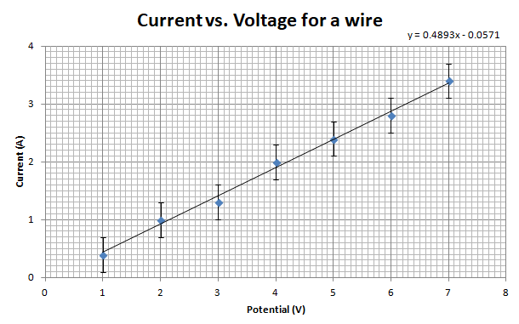

Voltage  V / V  ΔV ≈ 0 V | Current  I / A  ΔI = ±0.3 A
1.00 | 0.4
2.00 | 1.0
3.00 | 1.3
4.00 | 2.0
5.00 | 2.4
6.00 | 2.8
7.00 | 3.4

Again – don’t obsess over getting
even voltages. This isn’t real data.

