Internal Resistance of a Battery

When you draw current from a battery, the terminal voltage drops because all batteries or cells have an internal resistance which we can imagine as a small resistor in series with the cell. The formula then for the EMF, ε, is 𝜀 = 𝐼(𝑅+𝑟) where I is the current leaving the battery, R is the external resistance, and r the internal.

The model for a battery with internal resistance is this:
r
ε

What this means is that the terminal voltage of the battery (The voltage you would measure if you did so from the black dot to the black dot in the diagram above) will drop as you draw more and more current from the battery. In fact, if we look at the relationship between the current and the terminal voltage, it should be V_{t} = ε - Ir, where ε is the battery's EMF, I is the current we are drawing from it, and r is its internal resistance. If we graph V_{t} vs I, we will get a graph with a y intercept of ε, and a slope of -r, so that is the plan, to get the internal resistance from the slope of the best fit line.

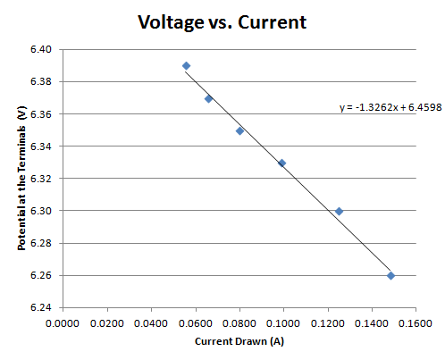 Notice how the terminal voltage is dropping as the current increases | A  V  The circuit you will use to measure voltage across and current drawn from the battery.

Directions -
35.0 V
5 Ω
0. With the light bulb unscrewed, read the unloaded terminal voltage of the battery, then screw it in.
1. Choose 5 - 10 different currents by sliding the variable resistor, and record for each the current in amps (mA/1000) and the potential in volts.
2. Graph V_{t} vs I, and put a trendline through the points, displaying the equation for the trendline.
3. Unscrew the light bulb, and turn off the meters unless there is someone waiting right there to do the lab.
4. Answer these questions:
a. What was the internal resistance of the battery?
b. How does the unloaded voltage you measured in step 0. compare to the y intercept of your equation?
c. As batteries wear out, their voltage drops more severely with current drawn. What is happening to their internal resistance? (why do you know?)

