**Group Work for 18IJ2-Double Popper’s Penguins** Name

**Round your answers to three sig figs (retain five), and show your work.**

**1**

37.0 V

4 Ω

7 Ω

6 Ω

3 Ω

21 Ω

9 Ω

13 Ω

17 Ω

Find:

A1 =

V1 =

V2 =

V3 =

Find the current through:

17 Ω

7 Ω

21 Ω

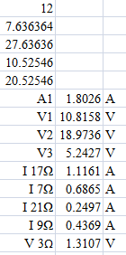

9 Ω

Find the Voltage across:

3 Ω

87.0 V

4 Ω

1 Ω

8 Ω

3 Ω

2 Ω

7 Ω

5 Ω

6 Ω

8 Ω

**2**

Find:

A1 =

V1 =

V2 =

V3 =

Find the current through:

5 Ω

3 Ω

6 Ω

7 Ω

Find the voltage across:

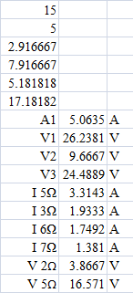

2 Ω

5 Ω

**3**

43.0 V

2 Ω

3 Ω

2 Ω

11 Ω

3 Ω

5 Ω

17 Ω

6 Ω

4 Ω

Find:

A1 =

V1 =

V2 =

V3 =

Find the current through:

11 Ω

4 Ω

5 Ω

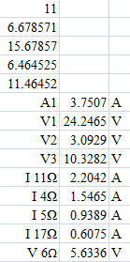

17 Ω

Find the Voltage across the:

6 Ω

**4**

31.0 V

1 Ω

2 Ω

3 Ω

9 Ω

7 Ω

11 Ω

4 Ω

3 Ω

Find:

A1 =

V1 =

V2 =

V3 =

Find the current through:

7 Ω

9 Ω

4 Ω

11 Ω

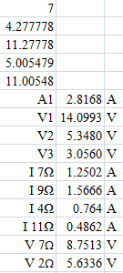Find the Voltage across the:

7 Ω

2 Ω