**Group Work for 18IJ-Single Poppers** Name

Find the readings on the meters:

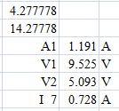1

A­1 =

17.0 V

5 Ω

3 Ω

2 Ω

11 Ω

7 Ω

V­1 =

V­2 =

Current through 7 Ω =

2

23.0 V

6 Ω

27 Ω

14 Ω

13 Ω

17 Ω

5 Ω

3 Ω

7 Ω

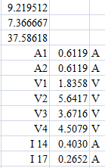A­1 =

A­2 =

V­1 =

V­2 =

V3 =

V­4 =

Current through 14 Ω =

Current through 17 Ω =

3

3 Ω

7 Ω

5 Ω

19 Ω

6 Ω

47.0 V

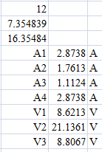

A­1 =

A­2 =

A­3 =

A­4 =

V­1 =

V­2 =

V­3 =

4

52.0 V

4 Ω

6 Ω

7 Ω

2 Ω

11 Ω

8 Ω

17 Ω

3 Ω

5 Ω

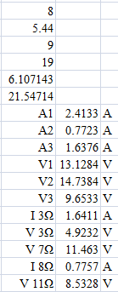A­1 =

A­2 =

A3 =

V­1 =

V2 =

V­3 =

Current through the 3 Ω

Voltage across the 3 Ω

Voltage across the 7 Ω

Current through the 8 Ω

Voltage across the 11 Ω