Vector Forces:

Find the net force on each charge:
A
B
C
34.0 cm
51.0 cm
+26.0 μC
-14.0 μC
+42.0 μC

A: 14.7 N right
B: 7.98 N left
C: 6.74 N left

Find the net force on each charge:
A
B
C
81.0 cm
19.0 cm
-42.0 μC
-16.0 μC
+12.0 μC

A: 4.68 N left
B: 52.0 N right
C: 52.3 N left

Find the net force on each charge:
A
B
C
16.0 cm
32.0 cm
+12.0 μC
+18.0 μC
+48.0 μC

A: 98.3 N left
B: 0 N
C: 98.3 N right

Vector Force 1: Each grid line is a meter. Charge A is +12.6 x 10⁻⁶ C, and charge B is +19.3 x 10⁻⁶ C,
and C is -25.1 x 10⁻⁶ C. Carry at least 4 sig figs for your calculations.
 |  |  |  |  | + | B | y
 |  |  |  |  |  |  |  |  |  |  |  |  | x
 | + | A |  |  |  |  |  |  |  |  |  |  | C

Calculate the force on charge A as a magnitude and a direction. The direction should be a trig angle. Draw the force vector above
 | magnitude | trig. angle | x-comp | y-comp
F_{BA}
F_{CA}
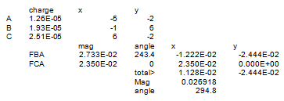 |  | F_{BA} + F_{CA}
 |  |  | Magnitude | Trig Angle

Calculate the force on charge B as a magnitude and a direction. The direction should be a trig angle. Draw the force vector above
 | magnitude | trig. angle | x-comp | y-comp
F_{AB}
F_{CB}
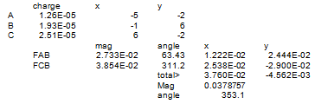 |  | F_{AB} + F_{CB}
 |  |  | Magnitude | Trig Angle

