IB Physics
16 E-I Group Quiz
Name
Show your work, and circle your answers and use sig figs to receive full credit.
3. Two parallel plates are separated by 15.0 cm. A 0.190 gram piece of Styrofoam is suspended between the plates against gravity by a voltage of 213 V from one side to the other. The top plate is positive. What is the charge on the Styrofoam? (is it + or -???)

4. A 0.240 gram piece of Styrofoam with a charge of +1.30 μC is suspended between two parallel plates separated by 10.0 cm. What is the voltage across the plates? Which plate is the positive one, the top or the bottom?

1. Point A has a gravitational potential of 563 J/kg, and point B has a potential of 237 J/kg. They are separated in a uniform gravitational field by 67.0 m of vertical distance. What is the field strength? Does the field point toward A or B? What force does it exert on a 17.0 kg mass? What would be the change in the potential energy of the mass if we moved it from point A 12.0 m toward B? Is it an increase or decrease?
(4.87 N/kg toward B, -82.7 N toward B, -993 J, decrease)

2. If you move 15.0 m South in a uniform electric field, your electrical potential increases by 45,300 V. What is the magnitude and direction of the electrical field? If moving a charge 3.00 m to the North increases the potential energy of that charge by +48.0 J, what is that charge, and is it positive or negative? What force does the field exert on the charge?
(3020 N/C North, -0.00530 C, Negative, 16.0 N South)

3. A uniform gravitational field exerts a force of 45.0 N on a 1.60 kg mass away from point B and toward point A. Point B is vertically displaced from point A by 23.1 m. What is the magnitude and direction of the gravitational field strength? What is the change in potential if we move from B to A? What would be the change in potential energy if we were to move the mass from B to A? Is it an increase or decrease? If A is at a potential of 154 J/kg, what is the potential at B?
(28.1 N/kg toward A, -650. J/kg change, -1040 J, decrease, 804 J/kg at point B)

4. The electric potential (voltage) changes from -127 V to -682 V when we move 92.0 m to the East in a uniform electric field. What is the magnitude and direction of the electric field? What force does it exert on a -390. μC charge? What would be the change in potential energy if we moved the -390. μC charge 15.0 m to the West? Is it an increase or decrease?
(6.03 N/C East, 0.00235 N West, -0.0353 J, decrease)

5. What is the magnitude and direction of the electric field 87.0 cm to the right of a +12.0 μC charge?  (1.43x10⁵ N/C right) | 6. We are 92.0 m from a point mass, and the gravitational field is 1.40x10⁻⁸ N/kg to the East. What is the mass, and where is it in relation to us?  (1.78x10⁶ kg, it is to the East of us)

7. Find the electric field at points p and q:
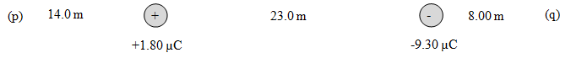
(p: 21.5 N/C left, q: 1290 N/C left)

8. Find the gravitational field at points p and q:
(p: 7.77 N/kg left, q: 12.2 N/kg left)

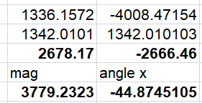
9. Find the electric field at point p. Draw the electric field vector, and label its magnitude and direction. Charge A is -4.70 µC, B is +3.80 µC, and each grid line is a meter. (3780 N/C right and down, 44.9º below the x axis)
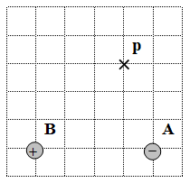

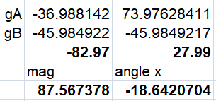
10. Find the gravitational field at point p. Draw the field vector, and label its magnitude and direction. Mass A is 6.20x10¹² kg, B is 7.80x10¹² kg, and each grid line is a meter. (87.6 N/kg left and up, 18.6º above the x axis)
