Noteguide for Coulomb's Law - Videos 16AB Name

- Charge is in Coulombs (C) (1C = 1 A·s)
  - Signed quantity (+/-)
  - e = 1.602x10⁻¹⁹ C
  - Protons are +, electrons are -
  - 1 C = 6.25x10¹⁸ electrons or protons
  - 1μC = 10⁻⁶ C
- Charge is conserved
- Likes repel, opposites attract

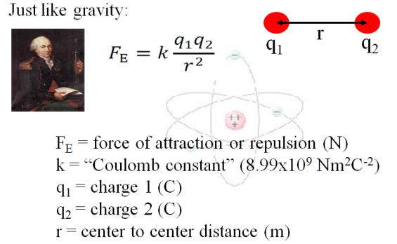
Example 1- What is the force of attraction between a helium electron and its nucleus if the electron is 1.7x10⁻¹⁰ m away? )

Example 2 – Two charged spheres have a force of repulsion of 5.40 N when their centers are 0.120 m apart. What is the force of repulsion when their centers are 0.360 m apart?

Whiteboards - Work these out - if you don't get the right answer, watch the video to see how to do it.
1. Jess Uwaite places a +3.0 µC charge 3.5 m from a +5.0 µC charge. What is the force of repulsion?  (1 µC = 10⁻⁶ C) (0.011N ) | 2. Noah Verkreinatlaad places a 5.0 C charge how far from a 3.0 C charge to make the force between them exactly 4.00 N? (1.8x10⁵ m or 180 km )
3. Cally Seniks measures a force of attraction of 4.50 N between two charges when their centers are separated by 1.20 m. What is the force of attraction when their centers are separated by 0.950 m?  (7.18 N ) | 4. Rita Book measures a force of attraction of 12.0 N between two charges when their centers are separated by 2.50 m. At what separation is the force of attraction 7.00 N?  (3.27 m )

Noteguide for Linear Arrays - Videos 16D1 Name

Find the net force on B:
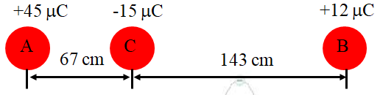

Write down the three steps:

Whiteboards - Work these out - if you don't get the right answer, watch the video to see how to do it.
Find the force on A:
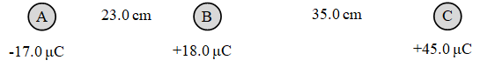
Find the force on B: (Use the force of gravity formula - , G = 6.67x10⁻¹¹ N m² kg⁻²
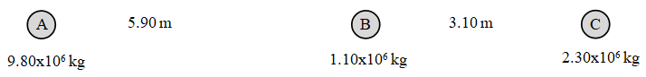

Noteguide for Non-Linear Arrays - Videos 16D2 Name

Find the net force on A:

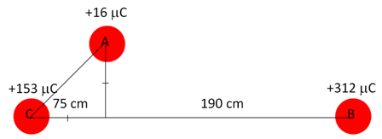

Write down the three steps:

Try this one:
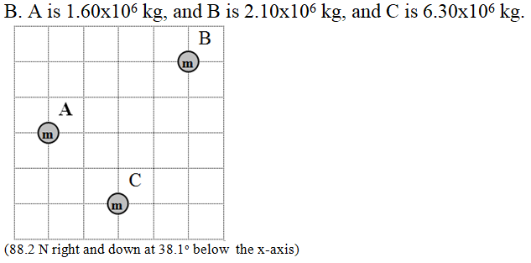
Use the force of gravity formula -
G = 6.67x10⁻¹¹ N m² kg⁻²

Noteguide for Field Theory - Videos 16E Name

Gravitational | Electrical

Field: 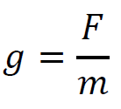  g - gravitational field strength (N/kg)  F - force exerted by field on the mass (N)  m - the mass (kg)  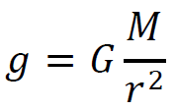  g - g near a point mass toward mass (N/kg)  G - 6.67x10⁻¹¹ Nm²kg⁻²  M - the mass (kg)  r - distance from the point mass (m) | Field: 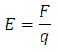  E - electric field strength (N/C)  F - force exerted by field on charge (N)  q - the charge (C)  (not in data packet)  E - E near a point charge away from charge (N/C)  k - 8.99x10⁹ Nm²C⁻²  q - the charge (C)  r - distance from the point charge (m)

Example 1 - A +125 μC charge experiences a force to the right of 0.0175 N. What is the Electric field, and its direction?

Example 2 - An electron travels through a region where there is a downward electric field of 325 N/C. What force in what direction acts on the electron, and what is its acceleration?

Whiteboards - Work these out - if you don't get the right answer, watch the video to see how to do it.
1.Ishunta Dunnit notices that a charge of -125 μC experiences a force of 0.15 N to the right. What is the electric field and its direction? (1200 N/C left) | 2. Doan Botherme places a +12 mC charge into an upward 160 N/C electric field. What force in what direction does it experience? (1.9 N up)
3.Alfred O. Dadark is on a planet where a mass of 0.12 kg experiences a downward force of 7.80 N. What is the gravitational field on the surface of this planet? (65 N/kg down) | 4. Telly Vishun places an unknown charge into a known upward electric field of 612 N/C, and the charge experiences a downward force of .851 N. What is the charge? (-1.39 mC)
5. Sal F. Hone levitates a 0.00125 kg ball with an upward electric field of 590 N/C. What is the charge on the ball?
(Hint gravity = electrical force) (+20.8 μC)
Eq = mg

Noteguide for Point Charges and Masses - Videos 16F Name

Field:  g - g near a point mass toward mass (N/kg)  G - 6.67x10⁻¹¹ Nm²kg⁻²  M - the mass (kg)  r - distance from the point mass (m) | Field: (not in data packet)  E - E near a point charge away from charge (N/C)  k - 8.99x10⁹ Nm²C⁻²  q - the charge (C)  r - distance from the point charge (m)

Example: What is the electric field 2.0 m to the right of a -21 μC charge?

Whiteboards - Work these out - if you don't get the right answer, watch the video to see how to do it.
1.Vera Similitude measures the electric field 13.5 m to the right of a -1.45 μC charge. What electric field in what direction?  (71.5 N/C to the left) | 2. Vesta Buhl measures an electric field of 2,120 N/C, 67 cm from a charge of unknown value. The electric field is away from the charge. What is the charge? (+0.11 μC)
3.Amelia Rate measures a gravitational field of 3.4 N/kg. What distance is she from the center of the earth?  (Me = 5.98 x 1024 kg.) (1.1 x 10⁷ m) | 4. Tara Bull measures an electric field of 10. N/C what distance from an electron? (12 μm)

Noteguide for Fields in Linear Arrays - Videos 16G1 Name

Field:  g - g near a point mass toward mass (N/kg)  G - 6.67x10⁻¹¹ Nm²kg⁻²  M - the mass (kg)  r - distance from the point mass (m) | Field: (not in data packet)  E - E near a point charge away from charge (N/C)  k - 8.99x10⁹ Nm²C⁻²  q - the charge (C)  r - distance from the point charge (m)

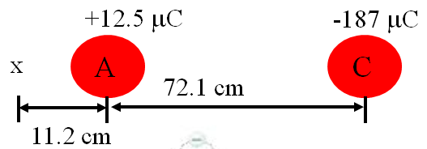

Example: What is the electric field at the x ?

Whiteboards - Work these out - if you don't get the right answer, watch the video to see how to do it.
1. Find the gravitational field at p: (49.0 N/kg to the left)
2.70x10²⁴ kg
8.20x10²⁴ kg

m

m
1.80x10⁶ m
(p)
9.10x10⁶ m

2. Find the electrical field at p: (51.6 N/C to the right)
21.0 m
(p)
13.0 m

+

-
+9.10 µC
-2.30 µC

Noteguide for Fields in Non Linear Arrays - Videos 16G2 Name
I think you will be OK if you pick only one of these. They are a lot like the vector force ones. If you do both that would be better - but I will leave that up to you.

Find the electric field at point p. Charge A is -3.20 µC, B is +4.40 µC, and each grid line is a meter.
(2640 N/C right and up at 28.1º with the x axis)

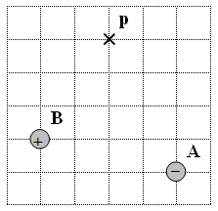

Find the gravitational field at point p. Mass A is 1.60x10¹² kg, B is 3.9x10¹² kg, and each grid line is a meter.
(21.5 N/kg right and down at 18.6º with the x axis)

