Noteguide for Conservation of Energy - Videos 16Q Name

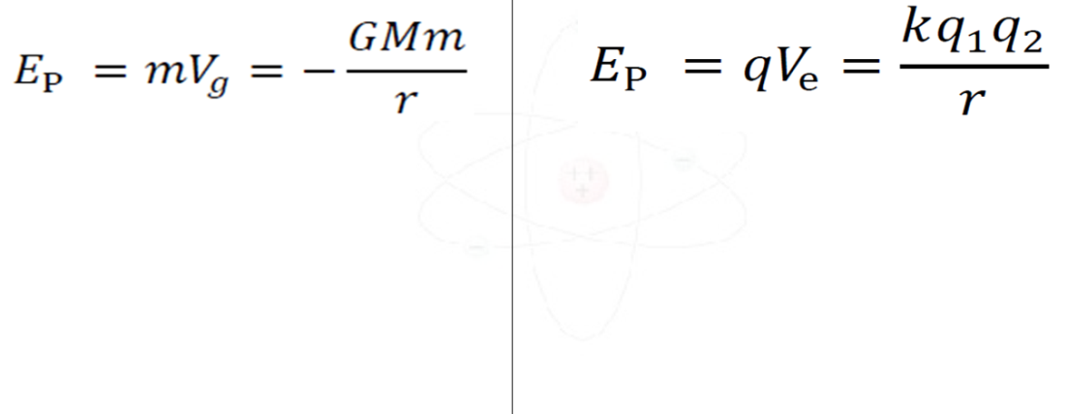

An 89.0 gram +2.30 µC charge is brought to 15.0 cm from a +1.10 μC charge. The 2.30 µC charge is released from rest, while the +1.10 μC is held fixed.

What is its speed when it is 37.0 cm away?

What is its speed when it is very far away?

(Do the gravity example on the back as well...)
Suppose you fired a 2.3 g rifle bullet at 1150 m/s straight up from the surface of the moon.
Mass = 7.35x10²² kg
Radius = 1.74x10⁶ m

A. What would be the greatest height it would reach?

B. What speed would it be going when it was 100. km above the surface?

D. What speed would it need to escape the moon’s gravity?

