Noteguide for RC Circuits - Videos 16P Name
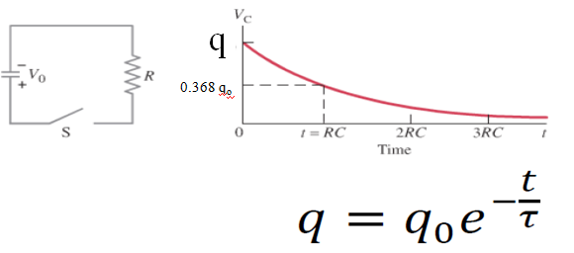
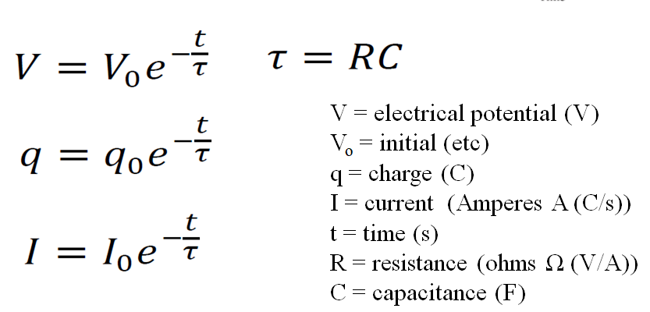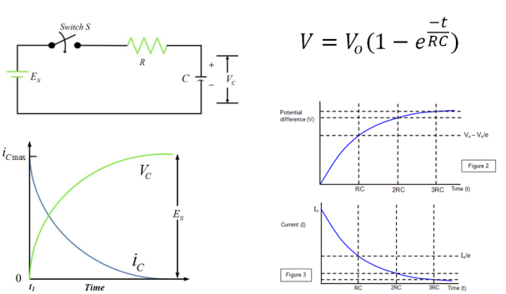

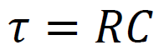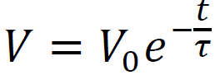
A 47.0 μF capacitor is charged to 12.0 V initially, and discharged through a 100. kΩ resistor.
What is its voltage at 13.0 s into the discharge? (0.755 V)

At what time does it reach 6.0 V? (3.26 s)

Whiteboards:
1. A 100. µF capacitor is attached in parallel with a 1.00 MΩ resistor. If it is initially charged to 5.00 V, what is the voltage 35.0 seconds after it starts to discharge? (3.52 V)

2. A 4.7 µF capacitor is attached to a 2.2 MΩ resistor in parallel. After 78 seconds of discharge there is 0.023 µC of charge on the capacitor. What was the original charge? (43 µC)

3. A discharging parallel RC circuit starts at 12.00 V, and after 312 s has reached 4.00 V. A. What is the time constant? B. What is the resistance if the capacitor has a value of 22.0 µF? (284 s, 12.9 MΩ)

4. A discharging parallel RC circuit has an initial discharge current of 195 mA, and is at a current of 162 mA at a time of 35.0 seconds into its discharge. What will be the current at 72.0 s? (133 mA)

