Noteguide for Capacitors - Videos 16O Name
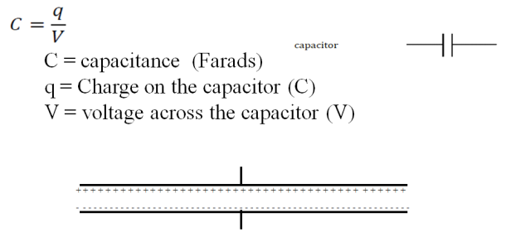
A CCD pixel has a capacitance of 1.7x10⁻¹² F. What is the voltage across it if it has been charged 6.0x10⁴ electron charges? (1 e = 1.602E-19)

Whiteboards:
1. What is the charge on a 250 microfarad capacitor if it has been charged to 12 V? (0.0030 C) | 2. What is the capacitance of a CCD pixel if it has 0.014 V across it when it has a charge of 2.13x10⁻¹⁵ C?  (1.5x10⁻¹³ F (or 0.15 pF))

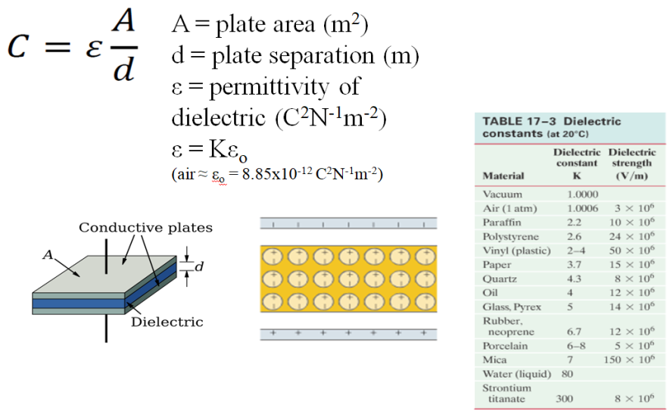
A 3.00 mm air gap capacitor has plates that measure 21.6 cm x 27.9 cm. (8.5”x11”) What is its capacitance?

Whiteboard: 1. A 47 µF electrolytic capacitor uses aluminum oxide as its dielectric (K = 9.1) If it has a plate area of 0.50 cm x 12.00 cm, what must be the thickness of the dielectric? (1.0 nm)

2. (Challenge for smart people only) You are designing a 1400 pF capacitor that must be able to have a peak voltage of 150 V. If you use neoprene as the dielectric,
A. What is the minimum gap you can use? (1.25x10⁻⁵ m)
B. What plate area must you have? (2.94x10⁻⁴ m²)

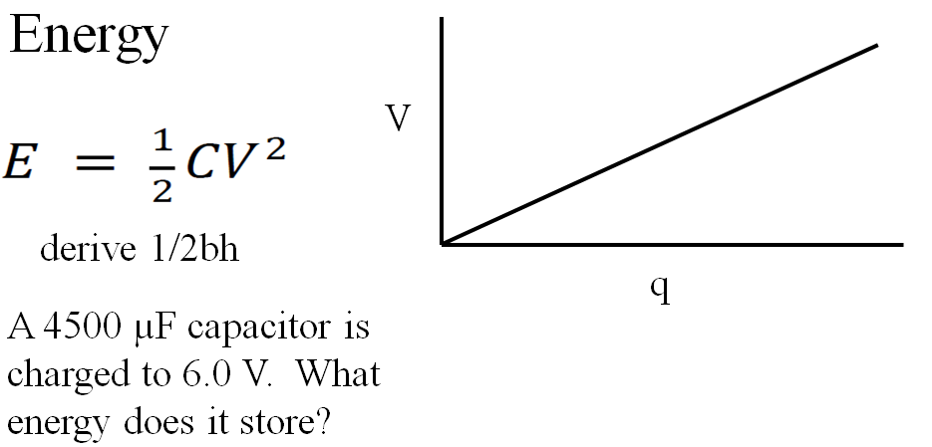

Whiteboards:
1. A camera flash requires a stored energy of 1.80 J. To what voltage must it charge a 4700 µF capacitor? (28 V)

2. What sized capacitor do you need to store 15 J of energy at a voltage of 12 V? (0.21 F)

3. What is the potential energy of 0.12 µC stored on an air gap capacitor with a plate area of 25 cm x 25 cm, and a plate separation of 1.0 mm? (Find C, then V, then E) (1.3x10⁻⁵ J)

What happens to the potential energy if the plates are moved so they are 3.0 mm apart? (Same charge) (3.9x10⁻⁵ J)

