Noteguide for CRT Problems - Videos 16N Name

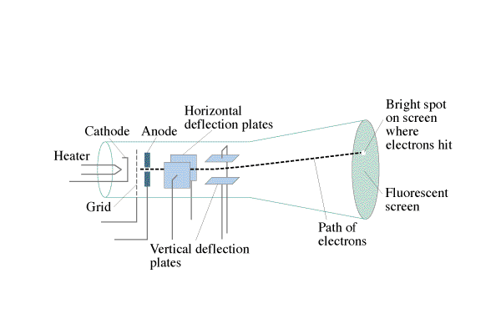

Part 1 - Acceleration toward the anode: Ve = ¹/₂mv²
Example - A CRT uses an accelerating potential of 5200. V. What velocity do the electrons have when they pass through the anode?

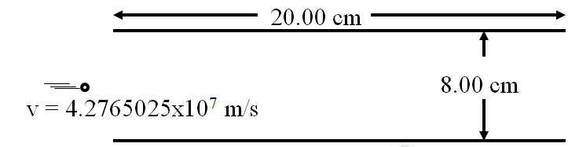

Part 2 - Steering the electron:
What voltage must be applied across the plates above to make the electron emerge from the other end 2.00 cm from the lower plate, assuming it starts parallel to the plates, and 4.00 cm from the lower plate? Which plate would be more positive?

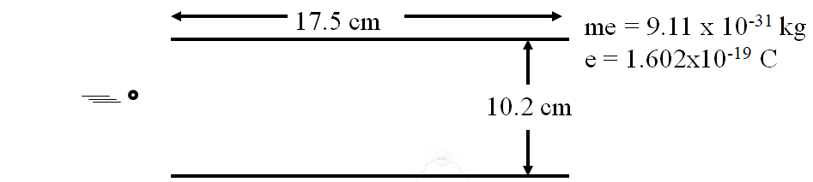

There is an electric field between these plates of 9420 V/m that makes the electrons that enter midway, nearly strike the bottom plate before they emerge from the plates.
What is the voltage across these plates?

What is the force on the electrons between the plates?

What is the downward acceleration of the electrons?

What time is the electron between the plates

What is the horizontal velocity of the electrons?

What voltage accelerated them to this speed before they got here?

