Noteguide for Movement in a field - Videos 16M Name

The work done to move a point charge is W = qΔVe, where ΔVe = Vf - Vi

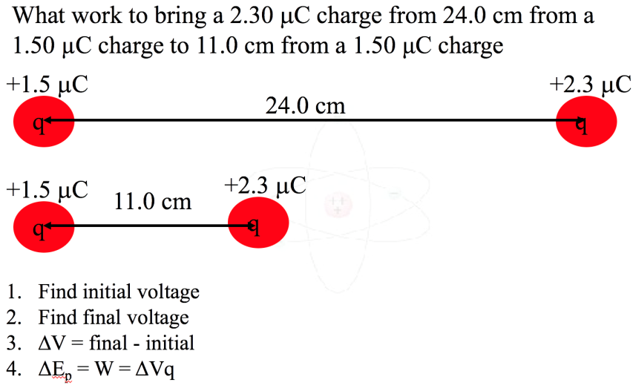

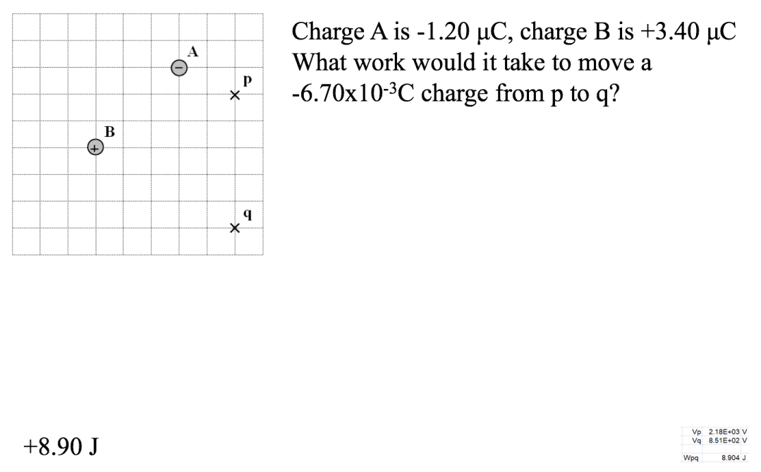

One More Example on the back with gravity

