Noteguide for Point Array Potentials - Videos 16L Name

The sum of the potentials due to an array of point charges or masses is the scalar sum of the individual potentials. (Scalar is like a number: 3+5=8)

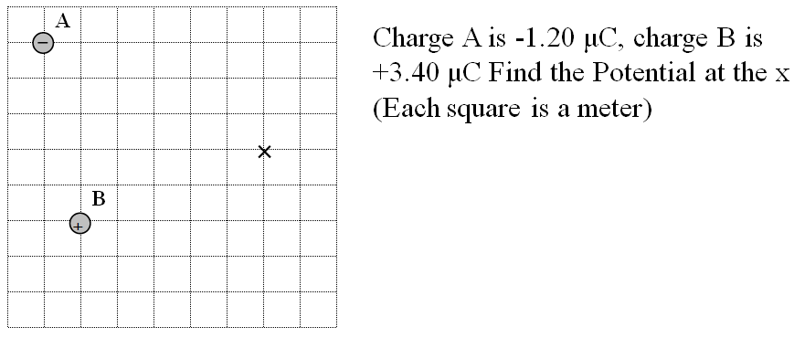

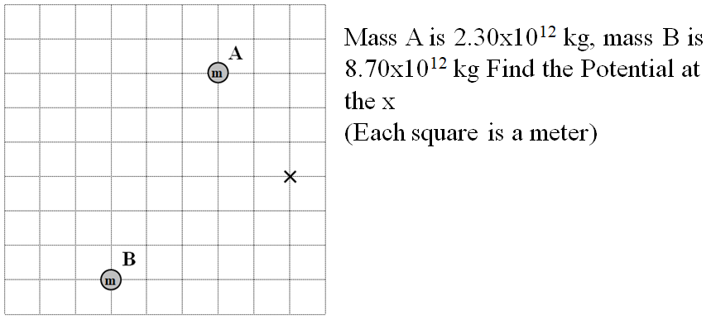

(I feel like if you watched those examples, you really don't need to do the whiteboards, but I put them on the back just in cases - so they are optional)

