Noteguide for Point Potentials - Videos 16K Name

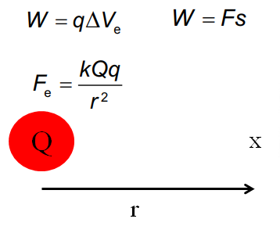
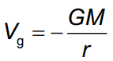  V_{g} = Potential at distance r  m = mass (kg)  r = distance (m) | 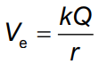  V_{e} = Potential at distance r  Q = charge (C)  r = distance (m)
Example 2: What is the gravitational potential on the surface of the moon? Mass = 7.35x10²² kg, radius = 1.74x10⁶m | Example 1: A van de Graaff generator has an 18 cm radius dome, and a charge of 0.83 μC. What is the voltage at the surface of the dome?

Whiteboards:
Lauren Order is 3.45 m from a -150. μC charge. What is the voltage at this point? (-3.91x10⁵V) | Alex Tudance measures a voltage of 25,000 volts near a Van de Graaff generator whose dome is 7.8 cm in radius. What is the charge on the dome? (0.22 μC)
What is the gravitational potential on the surface of the earth?  m = 5.97x10²⁴ kg, r = 6.38x10⁶ m (-6.24x10⁷ J/kg ) | At what distance from the center of the moon is the gravitational potential -1.00x10⁶ J/kg? Mass = 7.35x10²² kg  (4.90x10⁶ m )

