Noteguide for Fields in Non Linear Arrays - Videos 16G2 Name
I think you will be OK if you pick only one of these. They are a lot like the vector force ones. If you do both that would be better - but I will leave that up to you.

Find the electric field at point p. Charge A is -3.20 µC, B is +4.40 µC, and each grid line is a meter.
(2640 N/C right and up at 28.1º with the x axis)

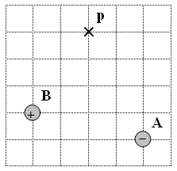

Find the gravitational field at point p. Mass A is 1.60x10¹² kg, B is 3.9x10¹² kg, and each grid line is a meter.
(21.5 N/kg right and down at 18.6º with the x axis)

