**Noteguide for Linear Arrays - Videos 16D1 Name**

**Find the net force on B:**

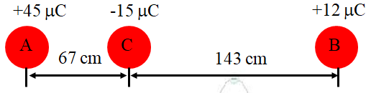

Write down the three steps:

Whiteboards - Work these out - if you don't get the right answer, watch the video to see how to do it.

|  |
| --- |
| **Find the force on A:** |
| **Find the force on B:**  (Use the force of gravity formula - , G = 6.67x10-11 N m2 kg-2 |