IB2 Mock Field Theory Test

1. A moon (B) orbits a planet (A).
The following data are available:
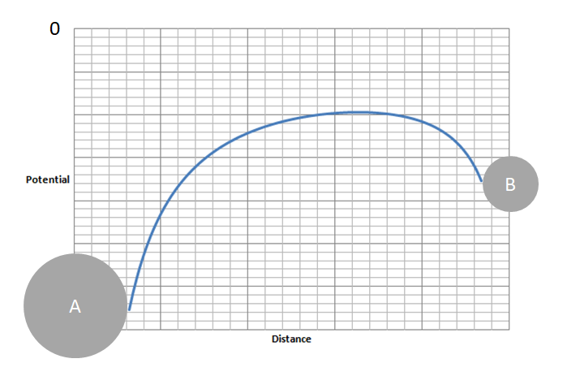
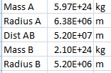

(Where Dist AB is the centre to
centre distance)

a. Label on the potential diagram above where there is no net gravitational field between the planet and the moon
b. Calculate the distance from the center of the planet to the point where there is no net gravitational field (3.26x10⁷ m)
c. Calculate the total gravitational potential at the surface of the moon due to the planet and the moon. (-3.54x10⁷ J kg⁻¹)

2. A satellite is in a circular orbit around a planet.
a. Outline why the gravitational force does not speed the satellite up.
b. Show that for all objects orbiting the planet, rv² = GM where r is the radius of orbit, v the velocity of orbit, and M is the planet's mass.

The following data are available:
Velocity of orbit of satellite A = 6470 ms⁻¹
Radius of orbit for satellite A = 8.40x10⁶ m
Radius orbit of satellite B = 7.20x10⁶ m

c. Calculate the velocity of satellite B (6,988 ms⁻¹)
d. Calculate the mass of the planet (5.27x10²⁴ kg)

3. An asteroid in deep space is going 2.30 km s⁻¹ when it is very far from Earth. It passes to within 4.10x10⁶ m of Earth's surface in its curving trajectory. The Earth has a mass of 5.97x10²⁴ kg, and a radius of 6.38x10⁶ m.
a. What is its velocity when it is closest to Earth? (9.016 km s⁻¹)
b. What distance is it from the surface of the Earth when its velocity is 4.60 km s⁻¹? (4.38x10⁷ m)

4. The electrical circuit shown is used to investigate the temperature change in a wire that is wrapped around a mercury-in-glass thermometer. A battery of emf (electromotive force) 46.0 V and of negligible internal resistance is connected to a capacitor and to a coil of resistance wire using an arrangement of two switches. Switch S1 is closed and, a few seconds later, opened. Then switch S2 is closed.
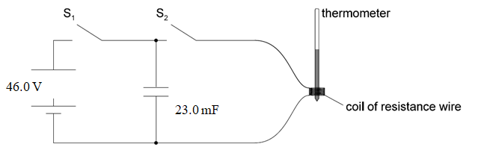
a. The capacitance of the capacitor is 23.0 mF. Calculate the energy stored in the capacitor when it is fully charged. (24.3 J)
b. The resistance of the wire is 15.0 Ω. Determine the time taken for the capacitor to discharge through the resistance wire. Assume that the capacitor is completely discharged when the potential difference across it has fallen to 1.00 V (1.32 s)
c. The mass of the resistance wire is 0.910 g and its observed temperature rise is 89.0 K. Estimate the specific heat capacity of the wire. Include an appropriate unit for your answer. (300. J kg⁻¹ ºC⁻¹)
d. Suggest one other energy loss in the experiment and the effect it will have on the value for the specific heat capacity of the wire.

