**IB Physics**

**16 HIKLM Group Quiz**

Name

**Show your work, and circle your answers and use sig figs to receive full credit.**

   

1. A 1.20 μC charge is moved from a potential of 14,500 V to 11,300 V. What **work** was done?
2. A 45.0 kg mass is moved from a potential of 1.45 J/kg to 5.60 J/kg. What **work** was done?
3. A -390. μC charge is at 5.00 V. If you do +1.50 mJ of work on it, what is the new **potential**?
4. A 16.0 kg mass is at a potential of 100. J/kg. If you do -318 J of work on it, what is the new **gravitational potential**?
5. A charge is moved from 5210 V to 11,150 V of potential. What is the **charge** if the work done was -56.0 mJ?
6. A mass is moved from 104 J/kg to 213 J/kg of gravitational potential. What is the **mass**, if the work done was 2410 J?

  (Assume all these fields are uniform)

1. Two horizontal metal plates are separated by 3.50 cm. A 12.0 V power supply is connected with the + side on the top plate, and the – side on the bottom plate. What is the magnitude and direction of the electric field between the plates?
2. Two vertical metal plates have an electric field of 560. V/m to the right between them. If there is a potential of 43.0 V across the plates, what is their separation distance, and which plate is the positive one, the right or the left?
3. Two horizontal metal plates separated by 10.2 cm have an electric field of 2450 V/m downward between them. What is the potential across the plates, and which plate is the negative one?
4. A mass of 5.65 kg is displaced vertically upward a distance of 4.50 m. What is the gravitational field if the work done is +78.0 J? (Find the change in Gravitational potential, then use that to find the field)

      (Assume all these fields are uniform)

11. Point A has a gravitational potential of 563 J/kg, and point B has a potential of 237 J/kg. They are separated in a uniform gravitational field by 67.0 m of vertical distance. What is the field strength? Does the field point toward A or B? What force in what direction does it exert on a 17.0 kg mass? What would be the change in the potential energy of the mass if we moved it from point A 12.0 m toward B? Is it an increase or decrease?

12. If you move 15.0 m South in a uniform electric field, your electrical potential increases by 45,300 V. What is the magnitude and direction of the electrical field? If moving a charge 3.00 m to the North increases the potential energy of that charge by +48.0 J, what is that charge, and is it positive or negative? What force does the field exert on the charge?

13. A uniform gravitational field exerts a force of 45.0 N on a 1.60 kg mass away from point B and toward point A. Point B is vertically displaced from point A by 23.1 m. What is the magnitude and direction of the gravitational field strength? What is the change in potential if we move from B to A? What would be the change in potential energy if we were to move the mass from B to A? Is it an increase or decrease? If A is at a potential of 154 J/kg, what is the potential at B?

14. The electric potential (voltage) changes from -127 V to -682 V when we move 92.0 m to the East in a uniform electric field. What is the magnitude and direction of the electric field? What force does it exert on a -390. μC charge? What would be the change in potential energy if we moved the -390. μC charge 15.0 m to the West? Is it an increase or decrease?

    So Eq = mg, since E = V/r these are (V/r)q = mg…

15. Two parallel plates are separated by 15.0 cm. A 0.190 gram piece of Styrofoam is suspended between the plates against gravity by a voltage of 213 V from one side to the other. The top plate is positive. What is the charge on the Styrofoam? (is it + or -???)

16. A 0.240 gram piece of Styrofoam with a charge of +1.30 μC is suspended between two parallel plates separated by 10.0 cm. What is the voltage across the plates? Which plate is the positive one, the top or the bottom?

 or 

17. What is the voltage 0.340 m from the center of a -12.0 μC charge?

18. An 18.0 cm radius Van de Graaff generator dome has a potential of -40,000 V at its surface. What is the charge on the dome?

19. What is the gravitational potential at the surface of the moon? It has a radius of 1.738x106 m and a mass of 7.35x1022 kg.

20. At what distance from the center of the earth (m = 5.97x1024 kg) is the gravitational potential -1000. J/kg?

21a. Find the electric potential **at point p and point q**. Charge A is -6.10 µC, B is +4.30 µC, and each grid line is a meter.

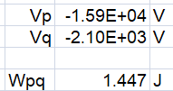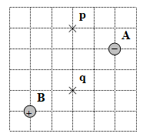

21b. What work would you do to move a +105 μC charge from p to q?

22a. Mass A is 6.30x1012 kg, mass B is 5.2x1012 kg. Find the gravitational potential at point p and q:

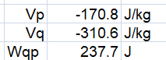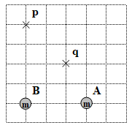

22b. What work would it take to move a 1.70 kg mass from point q to point p?

23. How much work would you need to do to move the 8.60 μC charge so that it is only 20.0 cm from the other charge?

(0.174 J)

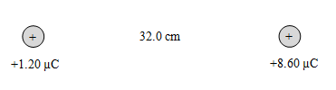

24. How much work to move the 15.0 kg mass to exactly the center between the other two masses? (1.14x109 J)

