Worksheet 15.3 - Thermodynamics Name
1. Consider this isobaric process for 0.9025 moles of an ideal gas.
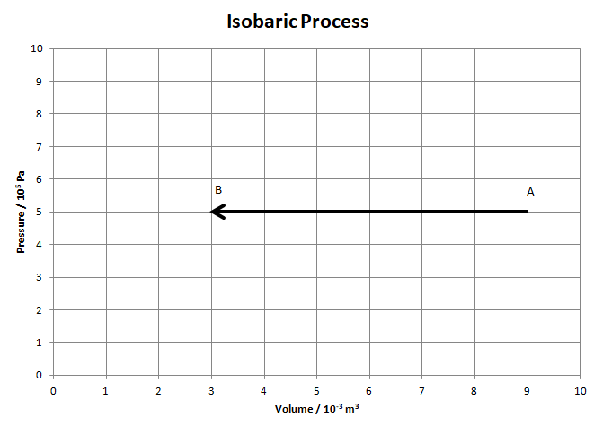
a. Calculate the temperature at A and B
(A: 600 K, B: 200 K)

b. Find Q, ΔU, and W for this process.
(Q = -7500 J, ΔU = -4500 J, W = -3000 J)

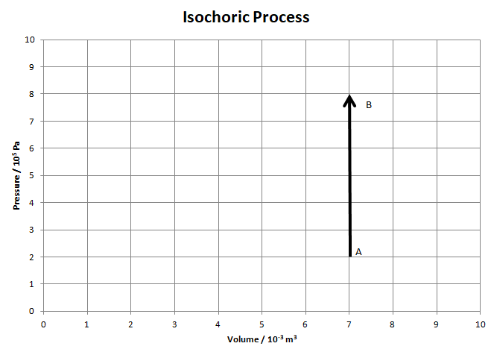
2. Consider this isochoric process. The ideal gas starts at A at a temperature of 120 K.

a. How many moles of gas are there in the cylinder? (1.40 moles)

b. What is the temperature at B? (480 K)

c. Find Q, ΔU, and W for this process.
(Q = +6300 J, ΔU = +6300 J, W = 0 J)

3. Consider the isothermal expansion AB for 0.4513 moles of an ideal gas. The gas starts at A with a pressure of 6.0x10⁵ Pa and a volume of 2.0x10⁻³ m³. At B the volume is 8.0x10⁻³ m³.
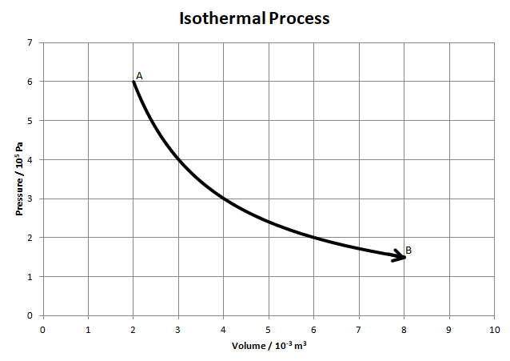
a. What is the temperature at A? How could you show that the process is isothermal? (320 K)

b. What is the pressure at B? (1.5x10⁵ Pa)

c. What is the temperature at B? (320 K)

d. The work done for this process is about +1664 J. Calculate the Q and ΔU. (Q = +1664 J, ΔU = 0)

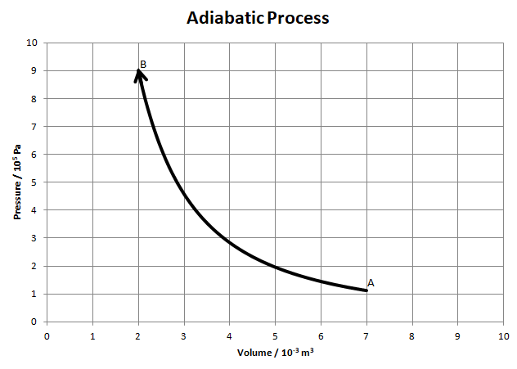
4. Consider the adiabatic compression AB. At point B (at the end) the gas is at a pressure of 9.0x10⁵ Pa, a volume of 2.0x10⁻³ m³, and a temperature of 850 K. It starts at a volume of 7.0x10⁻³ m³.

a. How many moles of gas are there?
(0.255 moles)

b. What is the pressure at point A?
(1.12x10⁵ Pa)

c. What is the temperature at point A? (369 K)

d. Calculate the Q, ΔU and W for this process. (Calculate ΔU first) (Q = 0, ΔU = +1529 J, W = -1529 J)

5. Consider the process ABCA for 1.45 moles of gas. The work done by the gas for process AB is 3955 J.
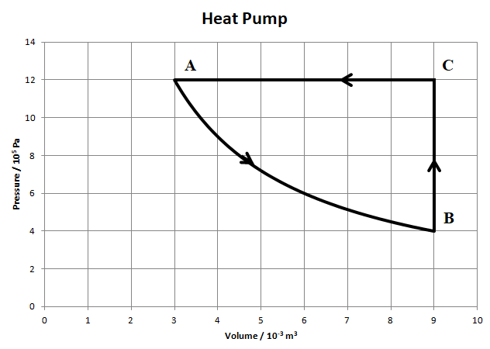
a. Show that process AB is isothermal. (Do some calculations)

b. Find the temperatures at the vertices A, B and C. (A: 299 K, B: 299 K, 896 K)

For each process calculate Q, ΔU, and W. Fill in the table:
 | Q | ΔU | W
AB | +3955 J | 0 J | +3955 J
BC | +10,800 J | +10,800 J | 0 J
CA | -18,000 J | -10,800 J | -7200 J
c. What is the net change in Q, U, and W for a complete cycle? What heat flowed in? What heat flowed out?
(Q = -3245 J, U = 0 J, W = -3245 J, Q_{in} = 14,755 J, Q_{out} = 18,000 J)

d. This is a heat pump. The overall “W” is provided by electrical energy, and the heat that flows in during process AB and BC comes from cooler air outside. The heat that flows out in CD heats your house. The ratio of this heat to the work we provide is called the COP (Coefficient of Performance) Calculate the COP for this heat pump (5.55)

6. Consider cycle ABCDA below. AB is an isobaric expansion, BC is adiabatic, CD is isochoric, and DA is isothermal. Point A is at a temperature of 350 K. The work done by the gas for BC is 1919 J. The work done on the gas for DA is 2707 J.
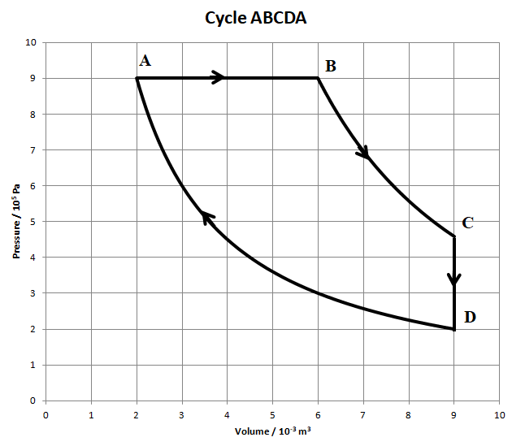
a. How many moles of gas are present?
(0.619 moles)

b. What is the temperature at point B? (1050 K)

c. What is the pressure and temperature at point C? (4.58x10⁵ Pa, 801 K)

d. State the temperature of point D. (350 K)

Fill in the table:
 | Q | ΔU | W
AB | 9000 J | +5400 J | +3600 J
BC | 0 J | -1919 J | +1919 J
CD | -3481 J | -3481 J | 0 J
DA | -2707 J | 0 J | -2707 J
What is the net change in Q, U, and W for a complete cycle? What heat flowed in? What heat was wasted? What is the efficiency of the cycle? (Q = +2812 J, U = 0 J, W = +2812 J, Q_{in} = 9000 J, Q_{wasted} = 6188 J, e = 0.312)

