Videos 15J2 - Carnot Cycle Name

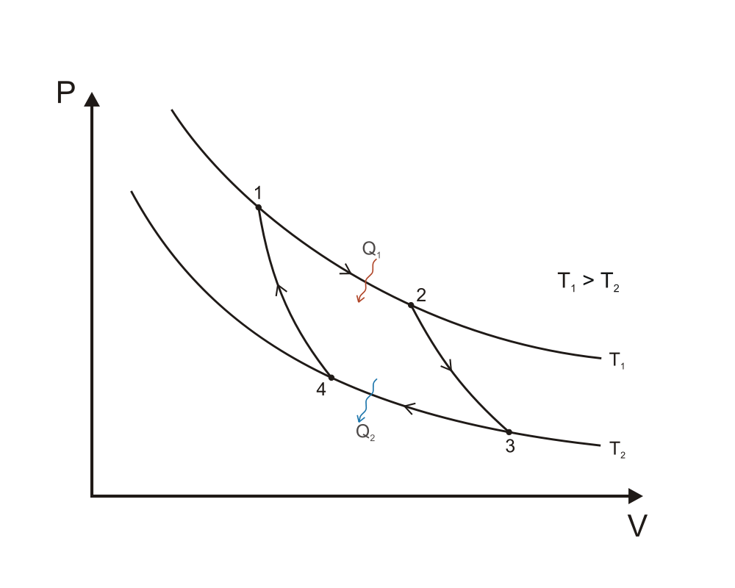

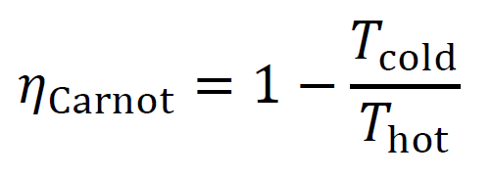 (Temps in K of course)

Processes: Q = ΔU + W
1-2: Isothermal Expansion:

2-3: Adiabatic Expansion

3-4: Isothermal Compression

4-1: Adiabatic Compression

Whiteboards: (These are solved on the website in the videos linked after the main one)
1. Amanda Huggenkiss operates a Sterling engine between the temperatures of 35.0 ºC and 13.0 ºC. What is the maximum theoretical efficiency she can achieve? (Carnot efficiency)  (.0714 or 7.14%) | 2. Amanda Huggenkis operates a Sterling engine between the temperatures of 35.0 ºC and 13.0 ºC. If the engine is to do 134 J of work, what heat must flow from the high temperature, and what heat is wasted?  Hint - we already know that efficiency = 0.071429  (1876 J, and 1742 is wasted )
3. Kahn and Stan Tinople have a heat engine with a Carnot efficiency of 0.35, if the low temperature is 285 K, what must be the high temperature? (Assume Carnot efficiency) (440 K) | 4. Olive Hughe has a heat engine that does 25.0 J of work, and wastes 41.0 J of heat during a cycle. If the low temperature is 20.0 ºC, what must be the high temperature in Celsius?  (Assume Carnot efficiency)  (472 K or 199 ºC )

