Videos 15G - Internal Energy Name
Write down what these things are:
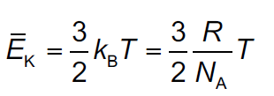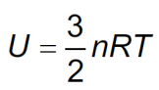

Example #1 – What is the total internal energy of a balloon full of Helium gas at STP. Assume the balloon is a 12.0 cm radius sphere.

Whiteboards: (These are solved on the website in the videos linked after the main one)
1. At what temperature does 0.450 mols of Neon gas have a total internal energy of 1250 J? (223 K or - 50.3 ºC) | 2. A Helium has an internal energy of 5610 J at a temperature of 45.0 ºC. How many mols do you have? How many grams? (m = 4.003 g/mol) (1.41 mols, 5.66 grams)
3. You have 12.0 grams of Neon gas at 20.0 ºC. What is its internal energy? (m = 20.1797 g/mol) (2170 J)

